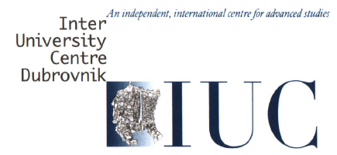 | I U C  INTER-UNIVERSITY CENTRE DUBROVNIK  Don Frana Bulica 4, HR-20000 Dubrovnik, Croatia  Tel: + 385 20 413 626 / 627, Fax: + 385 20 413 628, E-mail: iuc@iuc.hr
Inter-University Centre Dubrovnik Conference (IUC)
Theme: Communication & ICT for Social Change

Venue: Inter-University Centre Dubrovnik (IUC)

Dubrovnik (IUC), Croatia
Sep 3-5, 2018

PROGRAM
Sep 3, 2018 | Activities | Remarks
09.30 – 10.00 | Registration | Venue: IUC building
10.00 – 11.00 | Welcome Remarks & IUC & Dubrovnik Presentation  Nada Bruer  Executive Secretary, IUC | Venue: IUC building
11.00 - 11.30 | Keynote Address I :  Dr. Kjell Skyllstad  Emeritus Professor, University of Oslo & Chair of the Conference | Venue: IUC building
11.30 - 12.00 | Plenary 1: How Communication & ICT Facilitate Social Inclusion | Venue: IUC building
Dr. Kamolrat Intaratat
CCDKM, STOU
Co-host of the Conference
12.00 - 13.30 | Lunch | *own arrangement
13.30 - 16.15 | Plenary 2: How Communication & the Media Facilitate Social Inclusion | Venue: IUC building
13.30- 14.00 | Content Marketing: The Key to Brand Communication in the Digital Era  Advertising and Entertainment Business, Faculty of Management Science  Bansomdejchaopraya Rajabhat University | Pimpilai Thaipitak
14.00 – 14.30 | Development for value added of the Amphawa, Samut Songkhram Breadfruit (Artocarpus altilis) to a snack for commercial sale | Atchara Kaewnoi
14.30- 14.45 | break | *own arrangement
14.45- 15.15 | Factors Affecting the Decision on Participating in Tdej 3 Concert Bodyslam-The Power of Sharing Concert  (The Activities Following the Guidance of his Majesty the King Rama 9)  at Bansomdejchaopraya Rajabhat University | Parichart Suebsiriviriyakul  and  Nutt Dechapanya
15.15 – 16.45 | Media Role in Social Enterprise | Rem Bakadur, Nepal
16.45- 17.15 | The power of conversational platforms are able to enhance business potential.  Head of business computer, Faculty of Management Science, BSRU | Araya Sangmahachai
9 pm | Lindo Folk Ensemble at Lazareti  (Show time is 9.00 pm) | *own arrangement
Sep 4, 2018  09.30 - 10.30 | Keynote : Professor Dr.Peter Farkaš  Institute of Multimedia ICT, Slovak University of Technology (STU) and Institute of Applied Informatics, Pan-European University | Venue: IUC building
10.30- 10.45 | break
10.45-12.00 | Plenary 3: How ICT Facilitates Social Inclusion | Venue: IUC building
10.45-11.15 | Bridging the Digital Divide by Scholarly Communication.  Department of Information Science. Faculty of Liberal Arts. Sukhothai Thammathirat Open University, Thailand | Assoc. Prof. Dr.  Namtip Wipawin
11.15-11.45 | Future of Movie Theatre Industry in Thailand: The Impact of Digital Streaming Devices on the Movie Theatre Industry (Online Media versus Offline Media)  Mass Communication, Faculty of Management Science, Bansomdejchaopraya Rajabhat University | Manussawee Puatrakul
12.00- 13.00 | Lunch | *own arrangement
13.00- 13.30 | IUC Welcome Reception | IUC host
13.30 - 16.00 | Plenary 4: How Inter-disciplinary Communication and ICT Facilitate Social Inclusion
13.30 - 14.00 | Sharing Pain, Pleasure and Rage with the Citizens : Building Urban Partnerships for Social Change  Faculty of Communication Arts. Sukhothai Thammathirat Open University, Thailand | Prof. Dr. Kjell Skyllstad  Assoc. Prof. Dr.  Piyachat Lomchavakarn
14.00 - 14.30 | The Production Management of Fon Fah Arkard program on Royal Thai Army Channel 7  Mass Communication, Faculty of Management Science, Bansomdejchaopraya Rajabhat University | Nichapa Kaewpradub
14.30 - 14.45 | break
14.45 – 15.10 | The Study of Knowledge Management Model for Lecturers in the Faculty of Management Science  Faculty of Management Science, Bansomdejchaopraya Rajabhat University | Ms.Panna Poonpin
15.10 - 15.45 | Protein analysis and instruction media  Faculty of Science and Technology, Bansomdejchaopraya Rajabhat University | Hatairuk Tungkasen
15.45- 16.10 | The Relationship between Learning Style and English Proficiency of Bachelor’s Degree Students  Faculty of Education, Department of Educational Technology, Kasetsart University, Bkk, Thailand | Asst. Prof. Dr.  Sasichaai Tanamai
Sep 5, 2018  (whole day)  1st Farm | Excursion : Agrofarm visit at Brautovic Agroturizam & culinary delights of common lunch  by Professor Mato Brautovic | around 12 registered participants  *** 9.00 am leave IUC to the farm
2nd Farm | 1) The beautiful ancient island of Lokrum (20 minutes by ferry from the old port very much recommended) or  2) The other famous Agrofarm Konavoski Dvori | *own arrangement
Remarks : All meals & Coffee breaks & Excursion fee will be own arrangement
Lunch places : can be any place such as the nearby Orhan, Mimoza, etc.
Coffee breaks : available in the courtyard downstairs
Excursion cost : own arrangement (such as van rent, lunch)
IUC WIFI : will be available
Speakers & Attendees : 18- 20 persons (@2 Sep 2018)

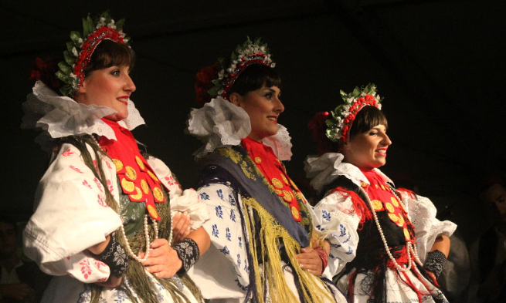
Picture of Lindo Folk (Local dances/ shows)

Site Visit : Sep 5, 2018

11.00 am Agrotourism farm by Prof Mato Brautovic agrotourism (lunch here too)
13.00 pm Visiting the Konavle seaside town of Cavtat
16:30 pm Departure from Cavtat for visiting the president of the Konavle agrotourism society
and the Vodopic family
17:30 pm Departure for Konavoski Dvori farm serving dinner
20:00 pm Return to Dubrovnik

*** Dr. Mato Brautović (Smart farm entrepreneur)
Assoc. Prof at the Department of Mass Communication at the University of Dubrovnik (Croatia), an adjunct lecturer at College of Journalism and Communication at the University of Florida (USA) and guest professor at the University of Montenegro (Montenegro) and Linnaeus University (Sweden)

