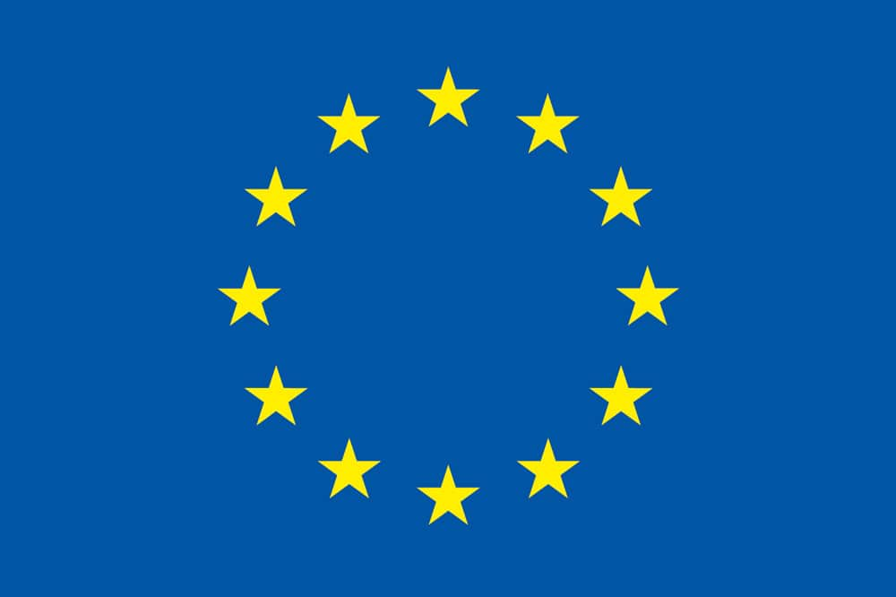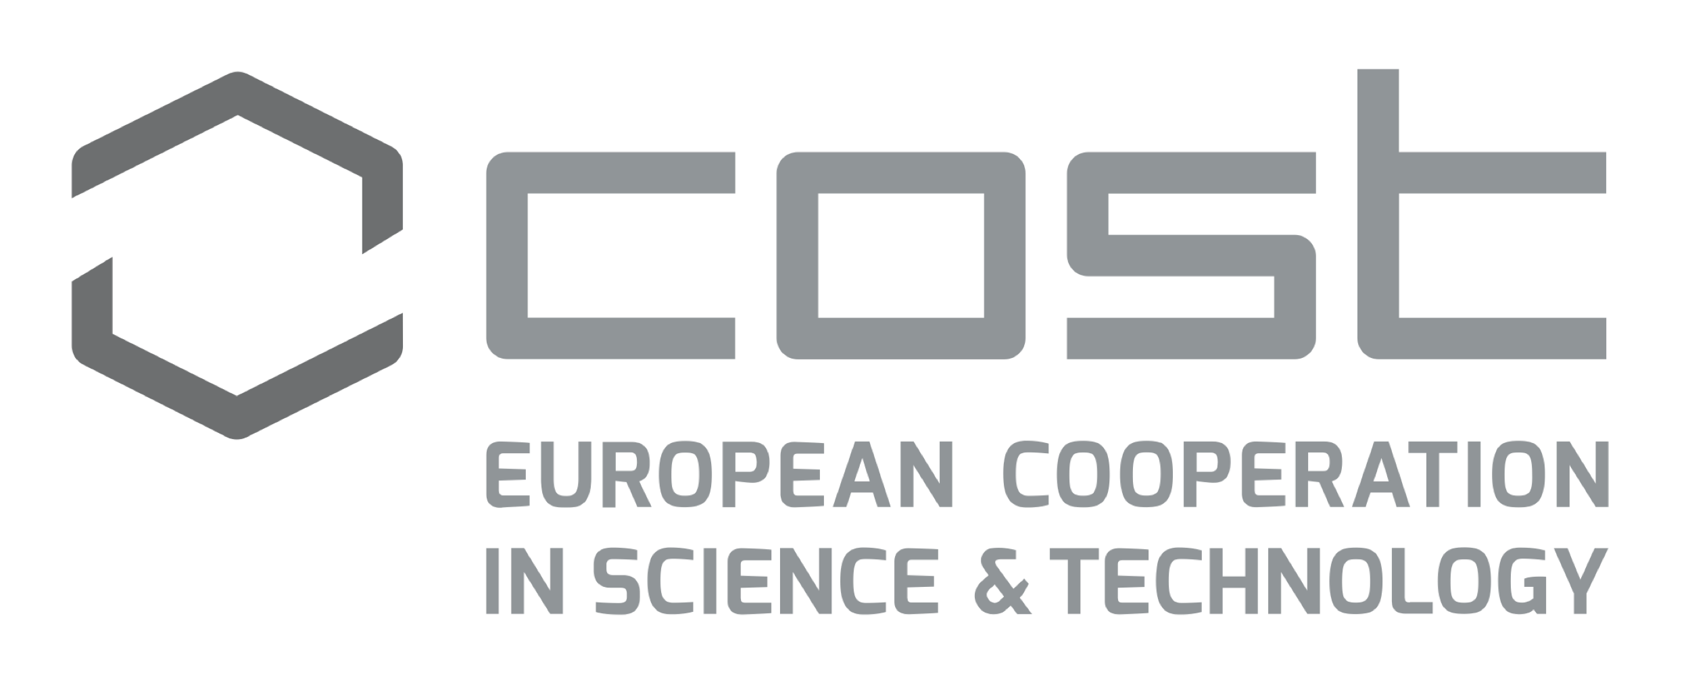

EU COST Action New Exploratory Phase in Research on East European Cultures of Dissent (NEP4DISSENT)
8th Graduate Spring School & Research conference on Comparative Media Systems
100 Years of Media Systems in Southeast Europe – the legacy of Yugoslavia
Inter University Center, Dubrovnik, Croatia, 15-20 April 2019
In cooperation with the ECREA CEE Network
AGENDA

Monday, 15 April 2019

9:30-11:00 Zrinjka Peruško, University of Zagreb
Introduction to the course & the EU COST Action New Exploratory Phase in Research on East European Cultures of Dissent (NEP4DISSENT)

Path dependency and critical junctures in comparative analysis of post-socialist media systems: the case of Southeast Europe

11:00-11:30 Coffee break

11:30-13:00 Zlatan Krajina, University of Zagreb
Media at the periphery

Lunch break

15:00-17:00 Film & discussion

Igor Mirković Sretno dijete – Documentary on new wave in music, Yugoslavia in the 1980’s

Tuesday, 16 April 2019

9:30-11:00 Paolo Mancini, University of Perugia
Media Systems in Central Eastern Europe: Between Institutionalism and Culture

11:00-11:30 Coffee break

11:30-13:00 Carmen Ciller, Universidad Carlos III de Madrid
Authoritarian experiences in Franco´s and Post Franco´s dictatorship: film and media in Spain

Lunch break

Doctoral student presentations

15:00 – 17:00
Snežana Bajčeta, University of Belgrade, Faculty of Political Sciences
How does legacy work in platform society?
Journalism between media and platforms in Southeast Europe

Dren Gerguri, University of Pristina
Media Systems research and post-Yugoslavian states: Case of Kosovo

Ana Hečimović, University of Zagreb
Media pluralism and diversity in six Southeast European countries

Wednesday, 17 April 2019

9:30-11:00 Antonija Čuvalo & Dina Vozab, University of Zagreb
Socialism as a factor of convergence or divergence: comparing media systems of socialist Yugoslavia

11:00-11:30 Coffee break

11:30-13:00 Snježana Milivojević, University of Belgrade
Legalizing freedom of speech: history of press/media legislation in Yugoslavia
Lunch break

Thursday, 18 April 2019

9:30-11:00 Marko Zubak, Croatian Institute of History, Zagreb
Yugoslav Youth Press: Communist Alternative Media

11:00-11:30 Coffee break
11:30-13:00 Vlatko Ilić, Faculty of Dramatic Arts, Belgrade
Representing Queerness: Yugoslavian and Post-Yugoslavian Media
Lunch break

15:00-16:30 Tarik Jusić, University of New York in Prague (UNYP)
Transplanting (In)dependent Media: Lessons from International Media Assistance in the Western Balkans
16:30-16:45 break

16:45 – 17:45 Aleksandra Dragojlov, Cardiff University
Genuine Domestic Change or Fake Compliance? The Pervasiveness of Politics in the Serbian Media Sector

Friday, 19 April 2019

9:00-13:00 Dina Vozab & Antonija Čuvalo, University of Zagreb

Methodological workshop: fsQCA - Qualitative comparative analysis of media systems using fuzzy sets (with one coffee break)

13:00 – 13:30 Closing ceremony, course evaluation, awarding of certificates

