
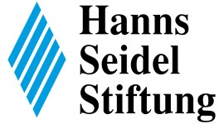





Causes, Faces and Consequences of Populism in the Global Political Context:
Ugly, Bad, and Sometimes Good?

Inter-University Center for Advanced Studies
Don Frana Bulića street 4, Dubrovnik
11 – 13 September 2017

Conference Program

11 September 2017

12:00 - Arrival and registration of participants
15:00 – 15:15 Welcome Address and introduction of participants
15:15 – 16:15 Round table: Few words about the state-of-the-art in studies of populism
Chairs: Kirk Hawkins and Levente Littvay
16:15 – 16:30 Coffee break
16:30 – 19:00 Panel 1 – Faces of Populism
- Does Populism Exist? Or Is It Just Contextual Manifestation of Authoritarianism? M. Murat Ardağ , Bruno Castanho Silva, Steffen Bandlow-Raffalski, Torsten J. Selck, J. Christopher Cohrs, Levente Littvay
- Attitudinal Species of Populism: Survey Evidence from Nine European Countries. Eva Anduiza, Marc Guinjoan, Guillem Rico
- It's Popular to Be Populist! The Social Desirability of Populist Attitudes. Fabian G. Neuner, Christopher Wratil
- Populism and Media Populism in Croatia: The Case of Most (The Bridge). Marijana Grbeša and Berto Šalaj
19:00 – 19:20
Invited presentation
Populism in Albania Albert Rakipi

21:00 Dinner - restaurant POKLISAR, Address: Ribarnica street 1.
12 September 2017

10:00 – 12:30 Panel 2 – Populist Framing
- Populist messages, populist sources and participation. Eva Anduiza, Marc Guinjoan, Enrique Hernández & Guillem Rico
- The same, only different: Effects of populist framing in Germany. J. Philipp Thomeczek, M. Murat Ardağ
- Five Star Movement Partisan Stereotyping. Alberto Stefanelli
- Constructing “the people” in late socialist Serbia: The case of letters to the press. Marko Grdešić
12:30 – 14:00 Lunch – buffet-style at the premises of the IUC.
14:00 – 16:00 Panel 3 - Populism and Emotions
- The role of emotions in the activation of populist attitudes. Allison Adams, Ethan Busby, David Doyle, Kirk Hawkins, Fred Wen Jie Tan, Nina Wiesehomeier
- Emotions as Moderators of Support for Populist Alternatives. Rosario Aguilar
- One and the Same? Reassessing the Causal Relation between Political Trust and Support for Populists. Bruno Castanho Silva, Levente Littvay
16:00 – 16:30 Coffee break
16:30 – 19:00 Panel 4. – Psycho-politics of Populism
- Polarizing Populism – Interventions for Amelioration. Jennifer McCoy
- Psychological Underpinnings of Populist Attitudes. Levente Littvay, Erin K. Jenne, Bruno Castanho Silva
- Individual differences, cognitive load and proclivity to vote for populist parties: the mock election experiment. Nebojša Blanuša & Kosta Bovan
- Populist Cognition. Ryan Carlin & Kirk Hawkins

21:00 Dinner - restaurant KOPUN, Address: Ruđer Bošković square 7.

13 September 2017

10:00 – 12:00 Round table: Policy recommendations – How to deal with populism today?
Chairs: Berto Šalaj and Nebojša Blanuša
12:00 – 12:30 Coffee break
12:30 – 13:45 Business meeting: Plans for the future
13:45 – 15:30 Lunch – buffet-style at the premises of the IUC and closing session.

Note: On 12 and 13 September, breakfast will be served in the restaurant ORHAN, Tabakarija street 1.

Important addresses on the map.
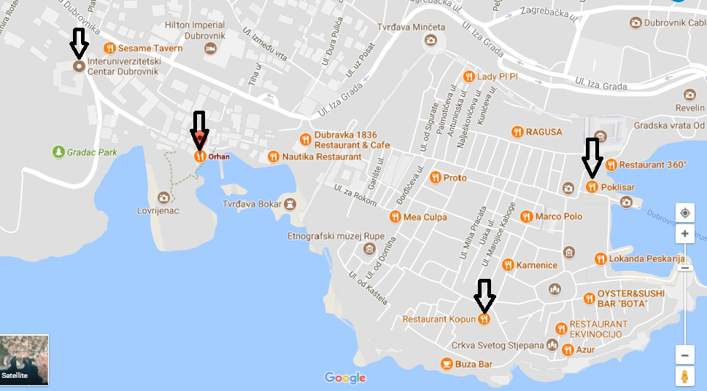
Restaurant ORHAN, Tabakarija street 1.
Inter-University Center, Don Frana Bulića street 4
Restaurant POKLISAR, Ribarnica street 1
Restaurant KOPUN, Ruđer Bošković square 7

For more information on arriving to Dubrovnik from the airport and local transportation, please visit the IUC site:
https://www.iuc.hr/transportation.php

