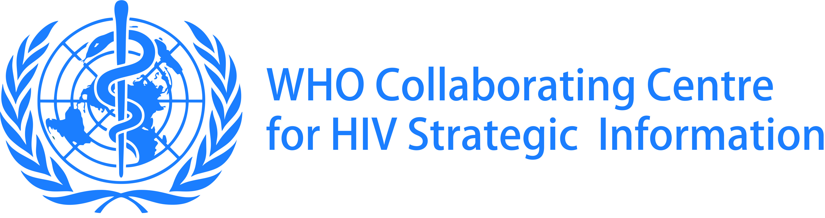

WHO COLLABORATING CENTRE FOR HIV STRATEGIC INFORMATION

Andrija Stampar School of Public Health, School of Medicine University of Zagreb

Rockefellerova 4, 10 000 Zagreb, Croatia
Phone: + 385 1 45 90 142/ 45 90 100; Fax: +385 1 46 84 212

www.whohub-zagreb.org

In collaboration with
Global Health Sciences, University of California, San Francisco

Training course
Using HIV Care and Treatment Cascades to Improve 90-90-90 Targets

19 – 23 March 2018, Dubrovnik, Croatia

Introduction

The main objective of the course is to enhance the skills of participants in analysis and use of the HIV “care cascade”, which is used to determine the magnitude of the losses and gaps along the continuum of HIV care and to explore reasons for these losses. The HIV care cascade is a way to show the proportion of individuals living with HIV who are engaged at each stage of HIV care, typically illustrated by a cascading bar chart. Cascades consist of a series of events in which each event is contingent on having achieved the preceding event until the final outcome is reached. The HIV care cascade enables to monitor the progress against 90-90-90 targets that the international community set towards achieving the Sustainable Development Goals and ending AIDS.

During the course, participants will learn how to construct and interpret cross sectional cascades, which provide national estimates of the 90-90-90 targets. Where there are strong individual-level reporting systems, HIV cascades can also be developed using data that follow individuals over time - this type of cascade is called a longitudinal cascade, or a cohort cascade. The course will also describe the ongoing efforts to standardize HIV prevention cascades and the stages of this cascade starting from testing (risk yield, referral to prevention services and retesting and retention in prevention). Prevention cascades generally start with the number of uninfected people at risk for HIV infection; people can then be followed across various prevention programmes with an endpoint of not becoming infected (key population services, PrEP, VMMC, and referral to community based prevention in local areas of high risk). However, linking prevention to clinical care should be done at each stage of the cascade.

In the second part, the course will provide a review of up-to-date and novel interventions that can be used to close the gaps in the HIV care continuum. During group work, participants will be able to construct various types of cascades using their own data (cross-sectional, longitudinal, KPs cascades, PMTCT and HIV co-infections cascades, HIV prevention cascades) or data given by facilitators.

The learning objectives are to:
- Learn how to implement cascade analysis, from data collection, description of indicators and analysis, to writing a report on the cascade analysis
- Understand and discuss data sources and tools needed for the cascade analysis, including HIV case-based surveillance and longitudinal patient monitoring
- Illustrate approaches to constructing and interpreting findings from cascades for prevention of mother-to-child transmission, HIV prevention and HIV co-infections with HBV, HCV and TB
- Describe stratification of the cascade by sex, age groups, risk groups and geographic areas, and utility of such analysis
- Present examples of the HIV cascade analysis done in a general population and in population sub-groups (pregnant women, people who inject drugs [PWID], men who have sex with men [MSM], female sex workers, transgenders, prisoners, young people, etc.)
- Learn how to use cascade data to target performance improvement and provide the most recent information on the effective and novel interventions to improve cascade indicators (HIV testing, linkage and retention in HIV treatment and viral load suppression)
- Interpret results of the cascade analyses in the context of biases and other limitations related to data availability and quality
- Conduct cascade data analysis and propose interventions that can address the gaps in the prevention and treatment continuum

Teaching Methods
The course consists of lectures, exercises and case studies.

There will be three options for group work/exercise:

Option A – a cascade analysis using de-identified data provided by the WHO Collaborating Centre

Option B – constructing an HIV cascade (including PMTCT, HIV co-morbidities cascade and prevention cascade) for a general population or disaggregated by sub-populations (FSW, MSM, PWID, etc.) and geographical areas by using most recent data that participants will bring from their countries.

Option C – use the cascade from Option A to discuss approaches of how to improve specific cascade indicators and how to measure change in the indicator in the short and medium terms.

Results of the cascade analysis will be presented by participants during the final day of the workshop.

Target Audience
Epidemiologists, social scientists, public health professionals

Course lecturers and facilitators:
Professor George W. Rutherford, MD, Global Health Sciences, University of California, San Francisco, USA

Associate professor Ivana Božičević, MD, MSc, DrPH, WHO Collaborating Centre for HIV Strategic Information, School of Medicine, University of Zagreb

Associate professor Brian Rice, BSc, MSc, PhD, Deputy Director of the Measurement and Surveillance of HIV Epidemics (MESH) Consortium, London School of Hygiene & Tropical Medicine, London, UK

Zoran Dominković, WHO Collaborating Centre for HIV Strategic Information, School of Medicine, University of Zagreb

Course organizer:
Lucija Šikić, University of Zagreb School of Medicine
lsikic@snz.hr; training@snz.hr

The course is held at:
Inter-University Centre Dubrovnik
Don Frana Bulića 4
HR-20000 Dubrovnik, Croatia
https://www.iuc.hr

Programme

19 March 2018
9.00 – 9.20 | Welcome and introductions
9.20-9.45 | Introduction to the HIV care cascade analysis and cascade definitions
9.45 – 10.30 | Data requirements for construction of the cross-sectional cascade
10.30 – 10.50 | Break
10.50 – 11.40 | Data requirements for construction of the cohort-based HIV care cascade
11.40 – 12.30 | Country presentations
12.30 – 13.30 | Lunch
13.30 – 14.30 | Importance of HIV case-based surveillance and patient monitoring systems in the cascade analysis
14.30 – 15.00 | Country presentations
15.00-15.20 | Break
15.20 – 16.00 | Measuring linkage, enrolment and retention in care
16.00-16.30 | Group discussion:  - What is the availability and quality of data for the sub-national HIV care cascade analysis?
20 March 2018
9.00 – 9.50 | Cascades for key populations with examples
9.50 – 10.30 | Exercise: Cascades for key populations
10.30 – 10.50 | Break
10.50 – 11.40 | HIV prevention cascade
11.40-12.30 | Exercise: HIV prevention cascade
12.30 – 13.30 | Lunch
13.30 – 15.00 | Cascades for care and treatment of HIV co-morbidities (Hepatitis B and C and TB)
15.00-15.20 | Break
15.20-15.40 | Syphilis care cascade
15.40 – 16.30 | Prevention of mother-to-child-transmission cascades

21 March 2018
9.00 – 9.50 | Key data quality challenges in the cascade analysis and interventions to improve quality of data
9.50 – 10.40 | Evaluating impact (HIV incidence and mortality data)
10.40 – 11.00 | Break
11.00-11.50 | Interventions to improve coverage of HIV testing and diagnosis
11.50 – 12.50 | Exercise: HIV testing coverage
12.50-13.50 | Lunch
13.50-14.10 | Introduction to the group work: Group work: Cascade data analysis, interpretation and recommendations for interventions
14.10 – 15.00 | Group work: Cascade data analysis, interpretation and recommendations for interventions
15.00-15.20 | Break
15.20 – 16.30 | Group work: Cascade data analysis, interpretation and recommendations for interventions
22 March 2018
9.00 – 9.50 | Interventions to improve linkage to care, ART initiation and retention
9.50-10.40 | Interventions to improve viral load suppression
10.40-11.00 | Break
11.00 – 11.40 | Interventions to improve impact: Decrease mortality and decrease HIV incidence
11.40-12.30 | Group work: Cascade data analysis, interpretation and recommendations for interventions
12.30 – 13.30 | Lunch
13.30 – 16.30 | Group work: Cascade data analysis, interpretation and recommendations for interventions
23 March 2018
9.00-10.20 | Presentations of group work
10.20– 11.40 | Break
11.40-12.30 | Presentations of group work
13.00 | Closure and lunch

