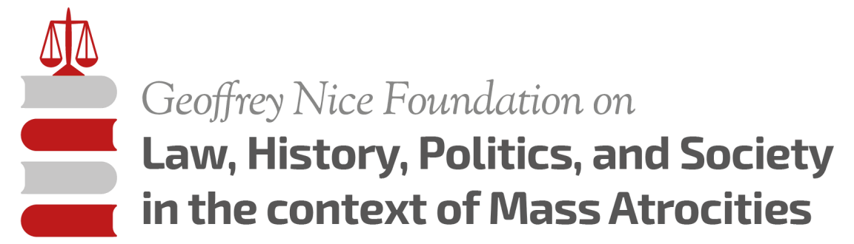

We are pleased to invite you to apply for participation at the fourth Master Class on Law, History, Politics and Society in the Context of Mass Atrocities, entitled:

**Law and Politics of Terrorism**

In Search of Adequate Political, Military and Legal Responses to the Threat of Terrorism in the post-Cold War Era

This Master Class is a joint venture between the Geoffrey Nice Foundation, the University of Amsterdam and the Serbian Helsinki Committee for Human Rights. It will take place from 03 to 14 July 2017 at the Inter-University Centre (IUC) in Dubrovnik, Croatia.

**Application deadline is 18 March 2017**

**CRITERIA:**

This Master Class is devised for MA, PhD and Post-PhD students in the fields of Law, History, Sociology, Politics, International Relations, Journalism, European Studies or related subjects.

**Please send your application, consisting of a CV and a short motivation letter, to:**

[geoffreynicefoundation@gmail.com](mailto:geoffreynicefoundation@gmail.com)

**SCHOLARSHIPS**

**There are two different kinds of scholarships**

* **10 scholarships** are made available by **ACCESS EUROPE**, a Jean Monnet Centre of Excellence **Erasmus+** programme and the **Geoffrey Nice Foundation**. These scholarships will be awarded to students from Dutch universities and from universities in South East Europe (Bosnia-Hercegovina, Croatia, Kosovo, Macedonia, Montenegro, Serbia and Slovenia). The maximum amount of any scholarship will be **EUR 1000** per student. **For students awarded these scholarships, the EUR 1000 will cover the IUC fee, reading material and lodging.** Travel and daily expenses will need to be covered personally by students.
* **3 full scholarships** are made available by the Croatian Ministry of Education for Croatian participant students. When applying for this scholarship the applicant will be asked to submit a copy of a Croatian ID or passport. **This scholarship covers travel expenses to and from Dubrovnik, lodging, IUC tuition fee and three meals per day.**

**TUITION FEES**

Applicants with no scholarship will be able to participate by paying a tuition fee that will cover the IUC fee, reading material and lodging which – for all students - is in two, three or four bed accommodation.

The tuition fee is set at **EUR 1000**.

If you are offered a place on the Master Class but have no scholarship, you will be kindly asked to transfer this amount – EUR 1000 - to the GNF bank account **two weeks prior** to the start of the Master Class on 03 July 2017, i.e. by c.o.b. Friday 16 June.

**ADDITIONAL EXPENSES**

The outstanding estimated MINIMUM costs - travel and the meals - for two weeks in Dubrovnik are **EUR 400** per student. These expenses are not included in the Access Europe - Erasmus+ - Geoffrey Nice Foundation scholarships.

**ACCOMMODATION**

Accommodation for all participants is at the cloister (*Samostan službenica milosrđa*) at *Branitelja Dubrovnika* Street 19, 2000 Dubrovnik. Rooms forstudents accommodate two, three or four participants. There is no provision of meals at the cloister; there are cooking facilities in the cloister and inexpensive cafes are nearby.

**COURSE DESCRIPTION:**

The first 25 years after the end of the Cold War have brought various security challenges for national states and the international community. The proliferation of violence - from inter-state wars, civil wars, guerrilla warfare, to terrorism - requires a whole range of mechanisms and responses.

This Master Class will deal with existing definitions of terrorism and will contrast them with other forms of political violence and warfare. The distinction will be made between armed conflict, guerrilla warfare / insurgency and terrorism. The following case studies will be discussed: (1) hybrid cases where a classical armed conflict, guerrilla warfare and terrorism go hand in hand (e.g. Syria); (2) guerrilla warfare used by insurgent groups in the protracted internal conflicts in some states of South America (e.g. Colombia); (3) terrorist attacks used as a means to destabilise Western democracies (e.g. Paris, Brussels etc.); (4) international and non-international armed conflicts (e.g. former Yugoslavia).

This Master Class will delve into these different manifestations of political violence and warfare, as well as their interaction and the responses available to confront or to deter them. The lecturers / seminar leaders – academics with backgrounds in law, history, political science and sociology, together with politicians, practising international lawyers and human rights activists – will assess the effectiveness of the different responses to these phenomena in order to identify the best possible ways forward in this increasingly complex area.

**OBJECTIVES**

The Master Class’s objective is to advance a multidisciplinary approach to understanding political violence and the role of international criminal justice through exploration of legal, historical, political and sociological methodologies.

**TOPICS:**

* The foreign fighter phenomenon and a couple of examples of how European states have responded to this phenomenon, and human rights concerns.
* The foreign fighters: “capita selecta”
* Terrorism as a means of advancing national (or nationalist) aims
* The Medium and the Message: Terrorism as Asymmetric Information Warfare?
* Is the West’s response to terrorism appropriate?
* The Balkans and Terrorism
* Security of Bosnia and Herzegovina and Kosovo: Legal Response to Terrorism
* The War on Terrorism“: but who is the Enemy and what is the War Zone?
* To achieve humanitarian objectives, do we need to talk to everybody?
* Military Responses to Terrorism: from Ireland, Afghanistan, Iraq to Syria
* International Security, Global Politics and the Donald Trump US Presidency
* The Deed of Commitment and fundamental humanitarian norms
* The Use of Military Force to Address Contemporary Security Challenges
* The end of the Conflict in Colombia: Peace without Justice?
* ICTY: Its History and its Legacy
* Towards an International Judiciary
* Prosecuting Slobodan Milošević at the ICTY
* Reporting war: local and international perspectives
* Is journalism the first draft of history?
* Post-Conflict Kosovo and Transitional Justice
* Background and Legitimacy of the Kosovo Special Court
* Justice and Security in the post-conflict Balkans

**FACULTY MEMBERS:**

1. Sonja Biserko, Helsinki Committee for Human Rights (Belgrade, Serbia)
2. Lord Iain Bonomy, former Judge at the ICTY (Glasgow, Scotland)
3. Jamie Brown, Legal Researcher, Council of Europe (Strasbourg, France)
4. Donald Ferencz, Planethood Foundation (USA/UK)
5. Sophia Kerridge, Barrister (London, UK)
6. Gordana Knežević, Journalist, Radio Free Europe (Prague, Czech Republic)
7. Marie-Ursula Kind, former ICTY lawyer, associate expert Swisspeace (Geneva, Switzerland)
8. Professor Gjylieta Mushkolaj, University of Pristina, (Prishtina, Kosovo)
9. Sir Geoffrey Nice QC, Inner Temple (London, UK)
10. Sir Nick Parker, former Commander of the UK Army in Afghanistan (London, UK)
11. Dr. Christophe Paulussen, Asser Institute (The Hague, the Netherlands)
12. Hamid Sabi, Lawyer and a Human Rights Advocate (London, UK)
13. Dr. Nevenka Tromp, University of Amsterdam, the Netherlands
14. Elisabeth Warner, Executive Director of Geneva Call (Geneva, Switzerland)
15. Professor Daniel Warner, (Graduate Institute of International Relations, Geneva, Switzerland)
16. TBD - a politician/ international leader from the time of the Balkan conflicts with experience relevant to the topics covered are expected to attend.

**Special guest lecture: Ben Ferencz, Nuremberg Prosecutor, by video or Skype, Planethood Foundation (USA/UK)**

**Contacts:**

Tel. 0031703223607; Mob.0031641338425; 00447860887536; 0041774739742

Email: geoffreynicefoundation@gmail.com