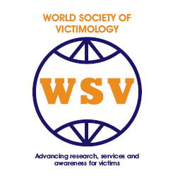
WORLD SOCIETY OF VICTIMOLOGY
In Consultative Status With the
United Nations ECOSOC and Council of Europe

World Society of Victimology
Application Form
2017 Dubrovnik Post-Graduate Course

Name_____________________________________________________________________________________

Title and Organization _________________________________________________________________

Address
______________________________________________________________
______________________________________________________________
______________________________________________________________

Telephone: _________________________________________________

Email: _______________________________________________________

I agree that this information is included in the
Membership Directory
( ) yes
( ) no

The WSV maintains an e-mail listserv through which messages about WSV events, announcements from the Executive committee, and other WSV news items are broadcast to our membership.

I wish to be subscribed to this e-mail listserv at my e-mail address listed above:
( ) yes
( ) no

Membership Type:
3 year student membership

Signature: ______________________________

OFFICE OF THE TREASURER
Prof. Dr. Chadley James
Assistant Professor
Department of Criminology
California State University, Fresno
P: 559.278.5416
E: chadleyj@csufresno.edu
World Society of Victimology (Treasurer)

