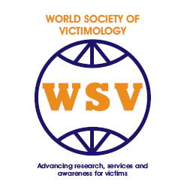

XXXII. International Post Graduate Course on Victimology, Victim Assistance and Criminal Justice

Inter-University Center Dubrovnik
Frane Bulica 4
Dubrovnik, Croatia

May 22 – June 3, 2017

Directors

Dick Andzenge
Chadley James
Gerd Ferdinand Kirchhoff
Marianne Hilf
Zvonimir Paul Separovic
Elmar G.M. Weitekamp

RECEIPT

€350

Name_________________________________________ Date: May 20, 2016

Dr. Chadley James ____________________ Date: May, 20, 2016

