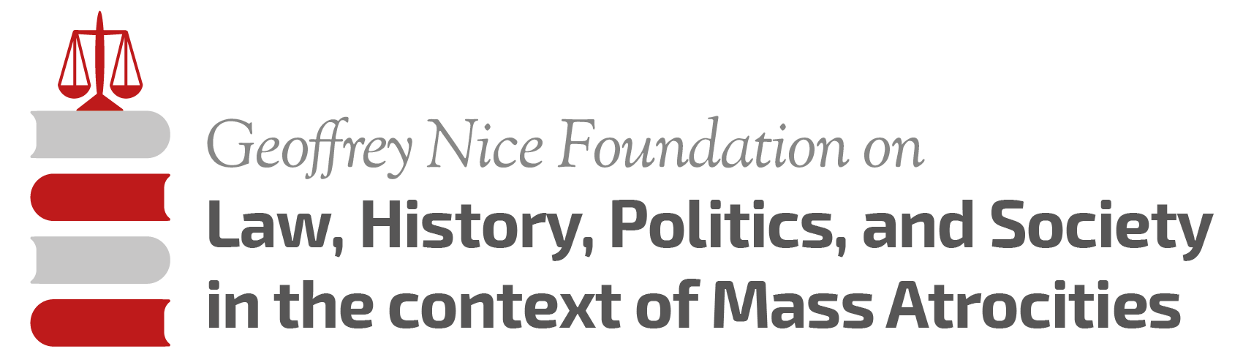

PRELIMINARY PROGRAMME MASTERCLASS 2015

DAY TWO Monday 29 June
09,00 – 11.00 – Nena Tromp “History of the Yugoslav Conflict”
11.00 – 11,30 – Break
11,30 – 13,30 – Bob Donia “The ICTY Through the Eyes of an Historical Expert Witness”
13,30 – 16,00 – Lunch Group Sessions
16,00 – 19,00 – Plenary Session and Film seminar

DAY THREE Tuesday 30 June
09,00 – 11,00 – Geoffrey Nice “History of the International Criminal Law”
11,00 – 11,30 – Break
11,30 – 13,30 – Iain Bonomy “Retributive Justice and the Mass Atrocities”
13,30 – 16,00 – Lunch Group Sessions
16,00 – 18,00 – Joanna Korner “The Challenges of Fairness in the International
Criminal Trials”
18,00-19,00 – Practical Exercise I

DAY FOUR Wednesday 01 July
09,00 – 11,00 – Geoffrey Nice/Nena Tromp “The Aetiology of Genocide and
Mass Atrocities”
11,00 – 11,30 – Break
11,30 – 13,30 – Sonja Biserko “Serbian State Project and Genocide”
13,30 – 16,00 – Break
16,00 – 19,00 – Kate Clark “Restorative Justice Mechanisms” and Film Seminar

DAY FIVE Thursday 02 July
09,00 – 11,00 – Joanna Korner “Genocide and ICTY: the Brdjanin Case”
11,00 – 11,30 – Break
11,30 – 13,30 – Iain Bonomy “Genocide charges and the Milošević trial”
13,30 – 16,00 – Lunch Group Session
16,00 – 18,00 – Practical Exercise II

DAY SIX Friday 03 July
09,00 – 11,00 – Kate Clark “Litigation for Reparations in BiH from 1992 to the present: what has been achieved?”
11,00 – 11,30 – Break
11,30 – 13,30 – TBD
13,30 – 16,00 – Lunch Group Session
16,00 – 18,00 – Practical Exercise III

DAY SEVEN Saturday 04 July
09,00 – 11,00 – Ben Rogers “Civil Society, Human Rights Activism and Fact
Finding: North Korea”
11,00 – 11,30 – Break
11,30 – 13,00 – Sonja Biserko “UN Commission of Inquiry for North Korea: What now?”
13,00 – 14,00 – Geoffrey Nice “North Korea and the ICC; Politics of Mass
Atrocities in North-Korea”
FREE AFTERNOON
18,00 – 20,00 – Film Seminar

DAY EIGHT Sunday 05 July
16,30 – 18,30 – Sightseeing of Dubrovnik starting at the IUC

DAY NINE Monday 06 July
09,00 – 11,00 – Bob Donia “Text, Context, and Pretext: Duelling Narratives at the
ICTY”
11,00 – 11,30 – Break
11,30 – 13,30 – Hikmet Karcic “The Srebrenica genocide and the BH judicial legacy”
13,30 – 16,00 – Lunch Group Sessions
16,00 – 18,00 – Bisera Fabrio “Role of the media in conflict and post conflict societies”

DAY TEN Tuesday 07 July
09,00 – 11,00 – Jakub Bijak “The BiH conflict in numbers: Focus on the Srebrenica massacre”
11,00 – 11,30 – Break
11,30 – 13,30 – Bert Bakker “Srebrenica and Political Responsibility: a Dutch perspective”
13,30 – 16,00 – Lunch Group Session
16,00 – 17.30 – Plenary Session
17.30 – 19.00 – Axel Hagedorn “Srebrenica Genocide and the UN”

DAY ELEVEN Wednesday 08 July
09,00 – 11,00 – Wolfgang Petritsch “Legacy of Mass Atrocities in BiH and
International Community”
11,00 – 11,30 – Break
11,30 – 13,30 – Axel Hagedorn “Srebrenica and liability of UN-member states within peacekeeping missions”
13,30 – 16,00 – Lunch Group Sessions
16,00 – 19,00 – Ejup Ganić “BiH after Srebrenica: Dayton Peace Accord and what went wrong with its implementation.”
20,00 – 24,00 – Farewell Dinner

DAY TWELVE THURSDAY 09 July
09,30 – 11,00 – Don Ferencz “How to End the War of Agression?”
11,00 – 11,30 – Break
11,30 – 13,30 – Sonja Biserko/Geoffrey Nice/Nena Tromp “Future of the
International Criminal System and the Legal Response to Mass Atrocities”
13,30 – 16,00 – Lunch
16,00 – 18,00 – Plenary Session
18,00 – 19,00 – The Evaluation

PROGRAMME SREBRENICA

DAY THIRTEEN Friday 10 June 2015
09,00 – – Departure form Dubrovnik by bus
15,00 – – Arrival to Srebrenica and sorting out the lodging
15,30 – 16,30 – Picnic lunch
16,30 – 19,00 – Visit to Potočari Memorial Centre
20,00 – 22,00 – Picnic dinner and the lecture by Hariz Halilovich "Memoralisation of Mass Atrocities in BiH"

DAY FOURTEEN Saturday 11 June 2015
08,00 – 09,00 – Picnic breakfast
09,00 – 13,00 – Potočari, attending commemoration and lecture by Dion van den Berg
13,00 – 14,00 – Picnic lunch
14,30 – 15,30 – Wartime Srebrenica
16,00 – 18,00 – Panel on Restorative Justice, the life of young people post conflict Srebrenica
19,00 – 21,00 – Picnic dinner and a meeting with Mothers of Srebrenica
22,00 – 24,00 – Free time
24,00 – 06.00 – Back to Dubrovnik

END OF THE COURSE

