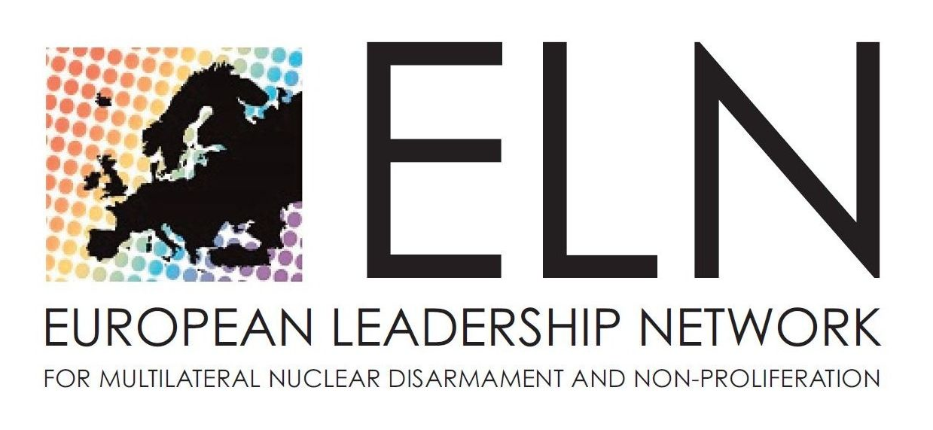
WAAS ELN University College

“International Conference on Nuclear Threats and Security”
September 14th – 17th 2012
organized by
The World Academy of Art and Science
The European Leadership Network
Dag Hammarskjöld University College of International Relations and Diplomacy

Draft Agenda

Inter University Centre, Dubrovnik, Frane Bulića 4

Friday 14th September
19:00-22:00 Get-together Reception

Saturday 15th September
9:00-10:00 Conference Opening Remarks
- Ivo Šlaus, president of World Academy of Art and Science (WAAS)
- Lord Des Browne of Ladyton, former Defence Secretary of the UK and Chair of the European Leadership Network (ELN)
- H.E. Kolinda Grabar-Kitarović, NATO Assistant Secretary General for Public Diplomacy
- President Ivo Josipović, President of Republic of Croatia

10:00-10:30 Coffee Break
10:30-13:00 Session I: Illicit Trade in Nuclear Materials-Regional Perspectives from South-Eastern Europe and the Black Sea Area - The Role of NATO
Moderator: Mustafa Kibaroglu, chair International Relations of Dept of Economics, Okan University, Turkey, member Pugwash council

Panellists:
- Simeon Anguelov, foreign secretary Bulgarian Academy, former Ambassasor to France and UNESCO, fellow of WAAS
- Colum Murphy, president Geneva School of Diplomacy, fellow of WAAS
- Representative of the Croatian Ministry of Foreign Affairs,
- Mladen Staničić, member of President’s Council of foreign affairs advisers, fellow of WAAS, former Director Institute for International Relations, Zagreb,
- NATO representative,
- Nebojša Nešković, director of TESLA accelerator Vinča, Serbia, chair of Nomination Committee WAAS
- Budimir Lončar, chair Council of foreign affairs advisers to Presidet, former minister of foreign affairs of the SFR Yuigoslavia, adviser to President Mesić of Croatia, UN representative in Jakarta

13:00-15:00 Lunch sponsored by the Croatian Ministry of Foreign and European Affairs
15:00-17:00 Session II: Nuclear Energy and Nuclear Weapons - Inter/Intra State Conflicts and WMD - The Role of NATO
Moderator: Lord Des Browne of Ladyton
Panellists:
- Sanja Bujas Juraga, Croatian Ministry of Foreign and European Affairs
- Alexander Nikitin, Director Centre for Political and International Studies, Moscow State Institute for International Affairs, member Pugwash Council
- Yuri Scherbak, Chair Institute for Sustainable Development of Ukraine
- Momir Djurović, president Montenegrin Academy of Sciences and Art, fellow WAAS
- Vladimir Knapp, professor emeritus University of Zagreb, former president of Croatian Pugwash
- Mustafa Kibaroglu,
- NATO representative,
- Luka Brkić, professor Faculty of Political Sciences, University of Zagreb

17:00-17:30 Coffee Break

17:30-19:30 Session III: Escaping the Winds of War - Nuclear Weapons Free Zones
Moderator: Paolo Cotta-Ramusino, secretary general of Pugwash, professor of Mathematical Physics, University of Milan, fellow of WAAS
Panellists:
- Giorgio La Malfa, former Minister of European Affairs of Italy and
participant of the ELN
- Hikmet Cetin, former Minister of Foreign Affairs of Turkey and
participant of the ELN
- Alyn Ware, Founder and International Coordinator, Parliamentarians for Nuclear Non-Proliferation and Disarmment, Councillor World Future Council, New Zealand
- Adele Buckley, member of Pugwash Council, Toronto, Canada
- Francesco Calogero, professor emeritus - physics, University of Roma, former secretary general of Pugwash and chair Pugwash Councuil, fellow WAAS
- Nebojša Nešković,
- Jasjit Singh, director Delhi Centre, India, fellow of WAAS

Free evening in Dubrovnik

Sunday 16th September
9:00 -11:00 Session IV: Sovereignty: the Right of Humanity, Global Governance and Nuclear Weapons
Moderator: Emil Constantinescu, former President of Romania (1996-2000), former rector University of Bucharest, member Board of Trustees of WAAS
Panellists:
- Zhelyu Zhelev, president of Bulgaria (1989-97 ), president Balkan Political Club, fellow of WAAS
- Winston Nagan, professor of law, University of Florida, member of the Board of WAAS
- Garry Jacobs, chair of the Board of Trustees of WAAS, vice-president Mother Service Society, Pondicherry
- Paul Walker, Green Cross International
- Yuri Nazarkin, Geneva School of Diplomacy
- Stela Petrova, Research Fellow, European Leadership Network (ELN)
- Goran Bandov, vice dean and professor, Dag Hammarskjold University College for International Relations and Diplomacy, Zagreb

11:00-11:30 Coffee Break
11:30-13:30 Session V: Re-examining the 1996 ICJ Advisory Opinion and Its Implication for Abolition of Nuclear Weapons - Flaws in the Concept of Nuclear Deterrence
Moderator: John Burroughs, UN Office of IALANA
Panellists:
- Winston Nagan,
- Francesco Calogero,
- Alyn Ware,
- Paul Walker,
- Kruno Pisk, Director General of InterUniversity Centre, Dubrovnik, fellow of WAAS
- Jasjit Singh
- Ivo Šlaus,

13:30- 17:00 Excursion to Ston
The excursion includes a visit to the medieval city of Ston - 7km long city walls, although we will not walk along the walls. The trip includes a boat journey in a bay of Mali Ston with oysters/mussels tasting and lunch.

17:30-19:00 Recommendations and Conclusions
Panellists:
Janusz Onyszkiewicz, former defence Minister of Poland and participant of the ELN
- Garry Jacobs,
- Winston Nagan,
- Paolo Cotta Ramusino
- Ivo Šlaus,

19:30 Press Conference - (Or preferably next day at 10:00 am)

Format of the conference
Reading Material: ELN and WAAS will prepare initial reading material which will be electronically distributed to all participants before 3rd September 2012.
Those who wish to send around their papers or any other relevant material are kindly asked to email them to the organizers at slaus@irb.hr by 31st August 2012.

Panel discussions: Moderators will introduce each topic at 7-10 minutes.
Each panellist is kindly asked to speak for 5-6 minutes.
Discussions will be open to all participants (each intervention should be no more than 4 minutes. Power-point presentation projector will be available. The discussions will be followed by comments from the panellists and conclusions by the moderator.

Recommendation and Concluding session: The moderator (or rapporteur as decided by the panel/moderator) of each session will present a summary (about 5 minutes). Four panellists will outline their summaries of the conference (each about 5 minutes), to be followed by Q&A from all participants.

Results: Declaration of the Dubrovnik conference; Proceedings – to be published: options – special NATO publication, journals of the World Academy and papers from the ELN (not mutually exclusive); Press conference.

Participants’ list:
Asterisks indicate fellows of WAAS

- President Ivo Josipović* and his staff, (TBC)
- Kolinda Grabar-Kitarović and/or her representative and staff, NATO
- Some Ambassadors accredited to Croatia (To be decided and confirmed)
- Lord Des Browne of Ladyton, former Defence Secretary of the UK and Chair of the
European Leadership Network (ELN)
- Hikmet Cetin, former Minister of Foreign Affairs of Turkey and participant of the
ELN
- Janusz Onyskiewicz, former defence Minister of Poland and participant of the
ELN
- Giorgio La Malfa, former Minister of European Affairs of Italy and participant of the
ELN
- Stela Petrova, Research Fellow, European Leadership Network, UK
- Shatabhisha Shetty, Deputy Director, European Leadership Network, UK
- Emil Constantinescu, former President of Romania (1996-2000), former rector University of Bucharest, member Board of Trustees of WAAS
- Zhelyu Zhelev, president of Bulgaria (1989-97), president Balkan Political Club, fellow of WAAS
- Garry Jacobs, chair of the Board of Trustees of WAAS, vice-president Mother Service Society, Pondicherry, India
- Winston Nagan (USA), professor of law, University of Florida, member of the Board of WAAS
- Jasjit Singh, director Delhi Centre, India, fellow of WAAS
- Simeon Anguelov, foreign secretary Bulgarian Academy, former Ambassasor to France and UNESCO, fellow of WAAS
- Nebojsa Nešković, director of TESLA accelerator Vinča, Serbia, chair of Nomination Committee WAAS
- Momir Djurović, president Montenegrin Academy of Sciences and Art, fellow WAAS
- Ivo Šlaus, president of WAAS, member Pugwash Council, Dean of Dag Hammarskjold University College for International Relations and Diplomacy, member of ELN
- Francesco Calogero, professor emeritus - physics, University of Roma, former secretary general of Pugwash and chair Pugwash Councuil, fellow WAAS
- Paolo Cotta Ramusino, secretary general of Pugwash, professor of Mathematical Physics, University of Milan, fellow of WAAS
- Adele Buckley member of Pugwash Council, Toronto, Canada
- Alexander Nikitin, Director Centre for Political and International Studies, Moscow State Institute for International Affairs, member Pugwash Council
- Mustafa Kibaroglu, chair International Relations of Dept of Economics, Okan University, Turkey, member Pugwash council
- Vladimir Knapp, professor emeritus University of Zagreb, former president of Croatian Pugwash
- Alyn Ware, Founder and International Coordinator, Parliamentarians for Nuclear Non-Proliferation and Disarmament, Councillor World Future Council,
- Paul Walker, Green Cross International (M. Gorbachev chairman)
- Yuri Scherbak, Chair Institute for Sustainable Development of Ukraine
- John Burroughs, UN Office of IALANA
- Colum Murphy, president Geneva School of Diplomacy, fellow of WAAS
- Yuri Nazarkin (Russia), Geneva School of Diplomacy
- Kruno Pisk, Director General InterUniversity Centre, professor University of Dubrovnik, fellow of WAAS
- Budimir Lončar, chair Council of foreign affairs advisers to President, former minister of foreign affairs of the SFR Yuigoslavia, adviser to President Mesić of Croatia, UN representative in Jakarta,
- Mladen Stanicic, professor, Dag Hammarskjold University College for International Relations and Diplomacy, former director Inmstitute for Interbnational Relations, Zagreb, fellow of WAAS
- Goran Bandov, vice dean and professor, Dag Hammarskjold University College for Interantional Relations and Diplomacy, Zagreb
- Marko Trnski, professor, Dag Hammarskjold University College for Interantional Relations and Diplomacy, Zagreb
- Luka Brkić, professor Faculty of Political Sciences, University of Zagreb

Local Arrangements:
Transfer on the ground: All participants arriving by plane at Dubrovnik airport will be met and transferred to their accommodation, and similarly for their departures. We will be happy to provide guidance and other necessary information for those arriving by car.
Venue: The conference is taking place at the Inter University Centre (IUC) on the first floor, Dubrovnik, Don Frana Bulica 4 (500m from the Old City).
Accommodation: Accommodation is provided in the IUC Dormitory (3rd and 4th floor). Unfortunately, there is no elevator and in the Convent (ground floor and first floor) which is 100m towards the old city. All rooms are with Air Condition and bathrooms. There are enough rooms in the Dormitory, but for those experiencing difficulties climbing the stairs, accommodation will be provided either in the Convent or in the Sesame restaurant facility. Please indicate your preference to Ivo Slaus at slaus@irb.hr.
Breakfasts and lunch will be served in the Sesame restaurant located between IUC and the Convent.
Reception and coffee breaks will be served in the patio of the IUC.

IMPORTANT
Please inform us as soon as possible of your flight schedule: arrival, flight number, departure, flight number
Please indicate your preference: IUC Dormitory or Convent
PLEASE REPLY AS SOON AS POSSIBLE AND NOT LATER THAN AUGUST 11, 2012 TO
slaus@irb.hr AND rathanea@rathanea.hr

Please send all your suggestions to help formulate the Dubrovnik
Declaration

Looking forward to seeing you in Dubrovnik

