# PRELIMINARY

**MONDAY 04 June 2012**

09.00 - 09.45 DEMARIN V: 23rd Summer Stroke School and its importance in spreading the awareness and knowledge about stroke in cooperation with CEESS and Research Group on Delivery of Neurological Services of WFN

09.45 - 10.30 DEMARIN V: Mirror neurons – Road map to enhancement of stroke recovery

10.30 - 11.15 DEMARIN V: The significance of stroke epidemiology research

11.15 - 12.00 DŽAKULA A: Stroke – what does it mean for public health

12.00 - 12.45 KADOJIĆ D: Prehospital delay after acute stroke in eastern Croatia

12.45 - 13.30 RUSSELL D: The unstable carotid artery plaque

14.15 - 17.00 **Workshop: Interesting stroke cases**

**TUESDAY 05 June 2012**

09.00 - 09.45 Van ELST H: Recent advances in US diagnostics

09.45 - 10.30 RUSSELL D: Cerebral emboli detection

10.30 - 11.15 MOROVIĆ S: Gender differences in stroke

11.15 - 12.00 VULETIĆ V: Cerebral vasoreactivity in type 2 diabetes - part II

12.00 – 12.45 ENZMANN F: Mytochondrial medicine in stroke and cerebrovascular disorders

12.45 – 13.30 TRKANJEC Z: Risk factors for dementia

14.15 - 17.00 **Workshop:** TRKANJEC Z: Stroke and dementia overlapping

**WEDNESDAY 06 June 2012**

09.00 - 12.0 HOW TO WRITE, READ, AND PUBLISH SCIENTIFIC PAPER?

Moderators: BORNSTEIN N, DEMARIN V, DŽAKULA A, RUSSELL D, TRKANJEC Z

12:00 – 12:45 BORNSTEIN N: Secondary stroke prevention

12:45 – 13:30 KORCZYN A: Vascular dementia

14.15 - 17.00 **Workshop: Interesting stroke cases**

**PROGRAMME**

**THURSDAY 07 June 2012**

09.00 - 09.45 NIEDERKORN K: Endovascular stroke therapy in Styria – an integrated approach

09.45 - 10.30 SIMU M: Stroke management - "The Golden Hour" project

10.30 - 11.15 KALVACH P: Cerebral haemodynamics in health and disease

11.15 - 12.00 DEMARIN V: New risk factrors for stroke

12.00 - 12.45 BARIĆ N: Relationship between glycemia level and common carotid artery IMT as predictor of atherogenesis

12.45 - 13.30 BORNSTEIN N: Time is brain – TIA as an emergency

19.00 **Workshop**: DEMARIN V: Mediterranean diet – food for brain

**FRIDAY 08 June 2012**

09.00 - 09.45 PETEK M: Subtypes of acute stroke in eastern Croatia

09.45 - 10.30 DIKANOVIĆ M: Spinal stroke

10.30 - 11.15 NIEDERKORN K: Carotid artery disease

11.15 - 12.00 KALVACH P: Imaging of cerebral parenchymal deterioration, ageing and ischemia

12.00 - 12.45 MOROVIĆ S: The importance of cerebral venous circulation

12.45 – 13.30 BENE R, DEMARIN V: Croatian Stroke Society AF prevention programme

14.15 – 15.00 ĐELILOVIĆ-VRANIĆ J: Extremely rare case of stroke in 1, 5 years old boy

15:00 – 17:00 Conclusion remarks, evaluation, final exam and closing of the course

Lunch will be served between 13.30-14.15

During the Stroke Summer School you are cordialy invited to participate in exciting social activites.

**The number of participants is limited and therefore an advance registration is strongly advised.**

Primary objective of the course is to encourage cooperation and to promote exchange of knowledge between participants from different countries. The course is a meeting of respected scientists that work with stroke presenting and discussing all major aspects of stroke risk factors, as well as new insights in epidemiology, prevention, diagnosis, treatment and rehabilitation of stroke. Probably the major feature of the course is enabling exchange of experience among experts and comparison of stroke data from various countries. Also, the course allows knowledge transfer between respected scientists from western countries and colleagues from central and east European countries working with stroke. Participants are kindly asked to arrange their travel to and accommodation in Dubrovnik. Our local organizers in Dubrovnik will be happy to help you.

**Directors of the course**:

Prof. Dr. Vida Demarin, University of Zagreb, Croatia

Prof. Dr. Roman Haberl, University of Munich, Germany

Prof. Dr. Kurt Niederkorn, University of Graz, Austria

Prof. Dr. Tanja Rundek, University of Miami, USA

Prof. Dr. Zlatko Trkanjec, University of Zagreb, Croatia

**Local organizers:** Dr. Mira Ivanković, Dipl. iur. Branko Bazdan,

Dr. Branko John, Dubrovnik General Hospital

**Registration fee: 750 HRK (100 Euro)**

Registration fee can be paid to the account of the Croatian stroke society:

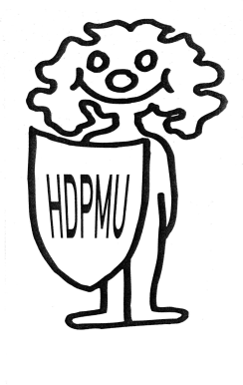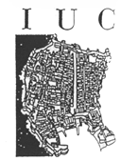Account number: 2485003-1100225825,

SWIFT: CROAHR2X, IBAN HR6324850031100225825,  
Croatia bank, Kvaternikov trg 9, Zagreb, Croatia

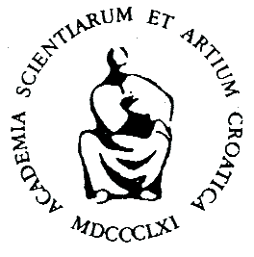

**Venue of the course:**

**Inter-University Centre**

Don Frane Bulića 4

HR-20 000 Dubrovnik, Croatia

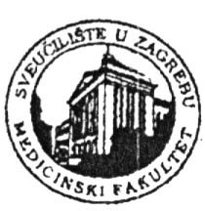Phone: +385 20 413 626, 413 627

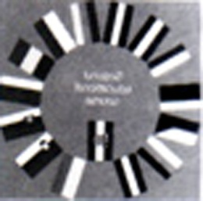Fax: + 385 20 413 628

E-mail: [iucdubrovnik@gmail.com](mailto:iucdubrovnik@gmail.com)

[iuc@iuc.hr](mailto:iuc@iuc.hr)

Web-site: [www.iuc.hr](http://www.hr.iuc)

**Under the auspices of**

**the Croatian Academy of Arts and Sciences**

**INTER-UNIVERSITY CENTRE DUBROVNIK**

## **CROATIAN STROKE SOCIETY**

**SCHOOL OF MEDICINE, UNIVERSITY OF ZAGREB**

**CENTRAL AND EASTERN EUROPEAN STROKE SOCIETY**

**RESEARCH GROUP ON DELIVERY OF NEUROLOGICAL SERVICES (RGODNS) OF WORLD FEDERATION OF NEUROLOGY (WFN)**

**Organize**

**International Postgraduate Course**

**23rd SUMMER STROKE SCHOOL**

**HEALTHY LIFESTYLE AND PREVENTION OF STROKE**

**DUBROVNIK, CROATIA**

**June 04-08, 2012**

**The Summer Stroke School is** **accredited by 4 ECTS points.**