



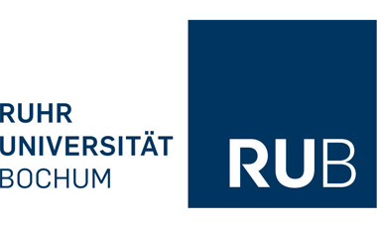

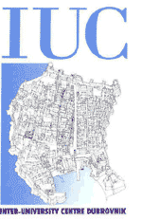

“The Diversity of Human Rights:
Debating Doubts about Human Rights Universalism”

07.09.-11.09.2026, Inter-University Centre Dubrovnik

Monday, September 1

10.00-10.15 Welcome by the course directors
10.15-11.30 Bernd Ladwig (Free University Berlin): „Introductin to the topic“
11.30-12.00 Coffee break
12.00-13.15 Dejan Pavlović (University of Belgrade): “Old and New Enemies of Human Rights”

16.45-17.45 Jan Rodin (University of Zagreb): “A Perfectionist Theory of Human Rights”.

18.00-19.00 Branimir Đurović (University of Belgrade): “Whose right to truth? Serbia’s ontological security and victimhood as a barrier to the right to truth and memory of minority communities in Serbia”

Tuesday, September 2

09.30-10.45 Nebojša Zelič (University of Rijeka): „Humanism as Preventing Evil and Sustaining Democracy“
10.45-11.15 Coffee break
11.15-12.30 Hans Feger (Free Universit Berlin): “The Abolition of the Person: On the Controversy between Kant and Carl Schmitt”

17.00-18.00 Tamara Crnko (University of Rijeka): „Can Self-Determination Accommodate Freedom to Immigrate? A Relational Account of Political Self-Government“

18.00-19.00 Beatrice Wurm (Free University Berlin): „Access to language skills as an integral part of Humanity as an Argument“

Wednesday, Sept 3

9.30- Trip to an island

Thursday, September 4

09.30-10.30 Arnd Pollmann (ASH Berlin): „Do you only have a right if you are able to exercise it?“
10.30-10.45h Coffee break
10:45h-11:45h Marco Russo (University of Salerno): “Humanity. The origins and structure of a word-destiny”
11:45h-11:50h Short break
11:50h-12:50h Darko Vinketa (University of Zagreb) “I Deceive, therefore I am:
Towards a Performative Ground for Universality”

Friday, September 5

10.15-11.30h Ivan Cerovac (University of Rijeka): “The Epistemic Justification of Public Shaming: From Moral Criticism to Collective Inquiry”

Coffee break

12.00 -12.45 Wrap up session

13.00-14.00 Director’s meeting

18.00- Fare well party

