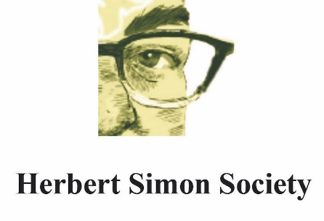
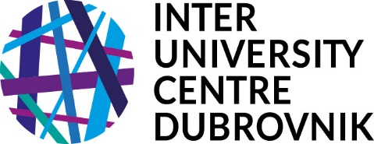

---------------------------------------------------------------------------------------
The 4th Annual Kathy Wilkes Memorial Conference
Inter-University Centre Dubrovnik (IUC)
24 – 25 April 2026

From then to now: the journey from the early days of the cognitive revolution to today’s AI challenges

From around the mid-20th century philosophers, psychologists, linguists, and fledgling neuroscientists joined forces in an effort to understand the mind and its workings. Almost 75 years on, we are seeing the fruits in the development of large language models and sophisticated robotics. In this workshop we will recall the early beginnings, and reflect on some of the intellectual twists and turns that led to today’s achievements. We also aim to honour one of the pioneer figures in cognitive science and artificial intelligence, who died in the summer of 2025, Professor Margaret Boden, OBE and FBA.

Friday, 24 April
14.00 – 14.40 Welcome and Introduction
Prof. Ivan Šimonović, IUC Director General, Dr. Anita Avramides, St. Hilda’s College, Oxford, Prof. Riccardo Viale, Herbert Simon Society, Ms. Nada Bruer Ljubišić, IUC Executive Secretary

14.40 – 15.55 Prof. Andy Clark: Generative Models in the Wild: From Cybernetics to LLMs and Back Again

15.55 – 16.25 Coffee Break
16.25 – 17.40 Ass. Prof. Mirela Fus-Holmedal: LLMs and Strong Plausible Deniability
17.40 – 18.55 Prof. Shaun Gallagher: Intelligence: From AI to ZI — Some lessons from myrmecology
20.00 Dinner

Saturday, 25 April
9.00 – 10.15 Ass. Prof. Remo Pareschi: Cognitive Sovereignty in the Age of Agentic AI
10.15 – 10.45 Coffee Break
10.45 – 12.00 Dr. Julija Perhat: Beyond AI Content Moderation: A Three-Tier Approach to Online Harmful Speech
12.00 – 13.15 Prof. Barry Smith: Artificial Intelligences and Us
13.30 Lunch

Honouring Kathy Wilkes
Dr. Kathleen Vaughan Wilkes (1946-2003) was a distinguished philosopher at Oxford University and a courageous defender of academic freedom. Her work spanned ancient philosophy, philosophy of mind, and cognitive science, but she is perhaps best remembered for her heroic efforts supporting underground education in Communist-controlled Eastern Europe.
From 1979, she worked alongside dissidents in Czechoslovakia, helping to bring about the Velvet Revolution. She remained in Dubrovnik during the 1991 siege, continuing to organize academic programs at the IUC even under bombardment. Her dedication earned her the Commemorative Medal from Czech President Václav Havel and honorary citizenship of Dubrovnik.
These conferences celebrate her interdisciplinary scholarship and her unwavering belief that education is a fundamental human right worth defending at any cost.

Organisers and Speakers:
Dr. Anita Avramides, St Hilda’s College, Oxford, UK
Nada Bruer Ljubišić, MA – Inter-University Centre Dubrovnik, Croatia
Dr. Paul Flather, St Antony's College, Oxford, UK
Prof. Andy Clark, University of Sussex, UK
Ass. Prof. Mirela Fus-Holmedal, Norwegian University of Science and Technology (NTNU), Norway
Prof. Shaun Gallagher, University of Memphis, United States
Ass. Prof. Remo Pareschi, University of Molise, Italy
Dr. Julija Perhat, University of Rijeka, Croatia
Prof. Snježana Prijić-Samaržija, University of Rijeka, Croatia
Prof. Barry Smith, University of London, UK
Prof. Ivan Šimonović, Inter-University Centre Dubrovnik, Croatia
Prof. Riccardo Viale, University of Milano-Bicocca; Herbert Simon Society, Italy

