

**Programme**

for the Course Language and Society

***“MetaCol – Collocations in the Light of Metaphors   
and Metonymies”***

3rd and 4th of October 2024

Inter University Centre Dubrovnik, Croatia

**Course venue:**

Inter University Centre Dubrovnik, Croatia

Ul. don Frana Bulića 4, 20 000 Dubrovnik

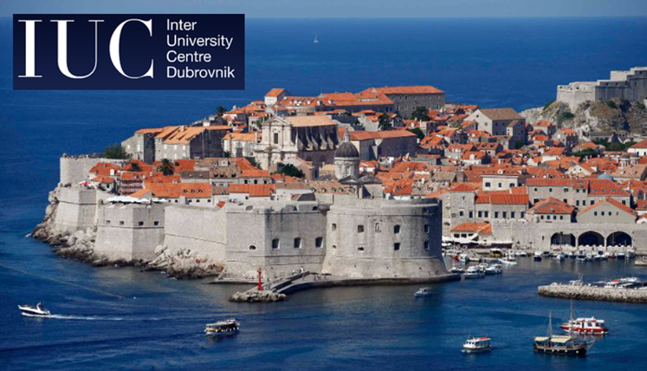

|  |  |  |  |
| --- | --- | --- | --- |
| **THURSDAY (3rd October 2024)** | | | |
| 08:30 – 09:00 | Registration (IUC Entrance Hall) | | |
| 09:00 – 09:15 | Opening ceremony (Room 4, Ground Floor) | | |
| 09:15 – 09:45 | **MetaCol Team (Dobrić Basaneže, Jurčević):** Introducing the MetaCol Project | | |
| 09:45 – 10:45 | **Plenary talk I – Zoltan Kövecses:** Collocations in CMT (**Chair:** Ch. Konecny) | | |
| 10:45 – 11:15 | Coffee break (IUC – Restaurant Atrium) | | |
|  | **SESSION I (English)** Room 4, Ground Floor **Chair:** J. Jurčević | **SESSION II (German)** Room 5, First Floor **Chair:** A. Stojić | **SESSION III (LLT English)** Room 6, First Floor **Chair:** L. Načinović Prskalo |
| 11:15 – 11:45 | **Jakop:** Defining Meta­phorical Colloca­tions in Relation to Idioms for Lexico­graph­ic Purposes | **Edelmann:** Metaphorische Kollokationen aus Sicht der Rechtsübersetzung (Deutsch/Spanisch) | **Matešić:** Balancing Freedom and Constraints: The Morphosyntactic Dynamics of Collocations |
| 11:45 – 12:15 | **Zhang:** Broken Body: Metaphors We Hurt By | **Targońska/Nawacka:** (Metaphorische) Kollo­ka­tionen der polnischen, deut­schen und russischen Rechtssprache im Ver-gleich | **Pavličević-Franić/ Aladrović Slovaček:** Se­man­­tic and Pragmatic Aspects of Collo­cations as Grammatical Constructions in Early Language Discourse |
| 12:15 – 12:45 | **Blagus Bartolec/Baer:** Metaphor and Metonymy in Croatian and Polish Verb Collocations | **Petkova-Kessanlis:** *Die Idee … ist so ein­fach wie einleuchtend*: Metaphori­sche Kol­­lokationen mit *einleuchtend* in wissen­schaft­lichen Texten | **Legac:** Teaching Figurative Language in Eng­lish as a Foreign Language to Pri­mary School Learners: Research into Practice and Opinions of Primary School Teachers in Croatia |
| 12:45 – 13:15 | **Srdanović**: Exploring Metaphorical Expressions by Means of Collocations: The Case of Japanese Adjective *takai* | **Zurolo:** Metaphorische Kollokationen in der Medi­zin: eine Fachtext­sorten­perspek­tive | **Kovač:** The Influence of Task Complexity on Syntactic Complexity and Accuracy |
| 13:15 – 14:15 | Lunch break (IUC – Restaurant Atrium) | | |
|  | **SESSION I (English)** Room 4 (Ground Floor) **Chair:** M. Matešić | **SESSION II (Computation & Translation)** Room 5 (First Floor) **Chair:** J. Jurčević |  |
| 14:15 – 14:45 | **Čulig Suknaić/Zovko Dinković:** Croa­tian and English Metaphorical Expressions for Moods: Why do we Feel Like the Weather? | **Brkić Bakarić/Načinović Prskalo/Jurčević:** Detecting Metaphorical Collocations through Zero-Shot Cross-Lingual Transfer with Multilingual BERT |  |
| 14:45 – 15:15 | **Vodanović:** Metaphor in Verbal Colloca­tions Expressing Emotions. Examples in Croatian and French | **Tadić:** Can Large Language Models Tell Us Something about Translating Colloca­tions? |  |
| 15:15 – 15:45 | **Máthé:** Space, Time and Transience | **Schmidt:** Translating Metaphorical Colloca­tions of the Type ADJ+N on the Example of English to Croatian Translation |  |
| 15.45 – 16.15 | **Karabalić:** Metonymische Phrasemkonstruktionen |  |  |
| 17:00 – 18:30 | Guided city tour | | |

|  |  |  |  |
| --- | --- | --- | --- |
| **FRIDAY (4th October 2024)** | | | |
| 09:00 – 10:00 | **Plenary talk II** **– Dmitrij Dobrovol’skij:** Metaphor as a Conceptual Basis for the Motivation of Multiword Units (Room 4, **Chair:** Ch. Konecny) | | |
| 10:00 – 10:30 | Coffee break (IUC – Restaurant Atrium) | | |
|  | **SESSION I (English)** Room 4 (Ground Floor) **Chair:** M. Matešić | **SESSION II (German)** Room 5 (First Floor) **Chair:** K. Dobrić Basaneže | **SESSION III (LLT – German)** Room 6 (First Floor) **Chair:** A. Stojić |
| 10:30 – 11:00 | **Holyk:** Metaphorical Conceptualiza­tion of Old Age: An Insight from Medical Humanities | **Sulikowska:** Metaphern, Idiome und Zwi­schen­phä­nomene – metapho­rische Projek­tions­prozesse im Coviddiskurs | **Chrissou:** Korpusorien­tier­tes Lernen zur Sprach­för­de­rung im Bereich der Phrase­ologie. Möglichkei­ten und Grenzen |
| 11:00 – 11:30 | **Giacomini:** Collocations Unveiling Con­cep­tual Networks: A Case Study in Learner's Lexicography | **Hornáček Banášová:** Modell der doppel­ten Si­gnifikation bei usualisier­ten präpo­si­tiona­len Wort­ver­bindungen in epistemi­scher modaler Bedeutung | **Frei/Nijemčević Perović:** Eine empiri­sche Ana­lyse der Kollokationskompe­tenz serbisch­sprachiger Germanistik­stu­die­ren­der |
| 11:30 – 12:00 | **Benčina/Moritz:** *Burning Waves* and *Epidemic Tails* – Creative Collocations in the Croa­tian Media Discourse during the Corona­virus Pandemic | **Funt:** Metaphern in deutschen Phrasem-Konstruktionen | **Księżyk:** Metaphorische Kollokatio­nen im Sprach­gebrauch deutsch-polni­scher Bilin­gua­ler auf der Grundlage des Kor­pus der deutsch-polnischen Zwei­spra­chigkeit LangGener |
| 12:00 – 12:30 | **Piedra Molina:** Exploring the Meta­phor­ical and Metonymic Meanings of the Word *Hand* in Chinese: A Corpus-Based Analysis | **Smykała/Miller:** Déjà-vu? Verbal-visuelle Kolloka­tio­nen auf den Covers briti­scher, deut­scher und pol­ni­scher Wochenzeit­schrif­ten | **Malechová:** Die Integra­tion des meta­phori­schen Lernens in den DaF-Unter­richt. Ein anwendungsbe­zogener Ansatz |
| 13:00 – 14:30 | Lunch break (IUC – Restaurant Atrium) | | |
| 14:30 – 15:30 | **Stojić, Konecny, Dobrić Basaneže, Jurčević:** Deeper Insights into the Results of the MetaCol Project & Future Pathways (Room 4, **Chair**: L. Načinović Prskalo) | | |
|  | **SESSION I (Morphosyntax) (English)** Room 4 (Ground Floor) **Chair:** M. Brkić Bakarić | **SESSION II (German)** Room 5 (First Floor) **Chair:** K. Dobrić Basaneže |  |
| 15:30 – 16:00 | **Matas Ivanković:** In Search of New Multi-Word Prepositions: Application of the Pattern Prepo­si­tion + Noun + Preposition | **Tsapaeva:** Erfassung und Darstellung mittel­nieder­deutscher metaphorischer Kol­loka­tio­nen im Wörter­buch. Eine exempla­rische Unter­su­chung auf der Grund­lage des Mittel­nieder­­deut­schen Hand­wörterbuchs |  |
| 16:00 – 16:30 | **Zaitova et al.:** Predicta­bility of Micro­syntactic Units across Slavic Languages: A Translation-Based Study | **Agnetta:** Das immer­gleiche Versatz­stück? Die barocke Gleichnisarie im Lichte von Kookkurrenz und Kollokation |  |
| 16:30 | Closing ceremony (Room 4, Ground Floor) | | |