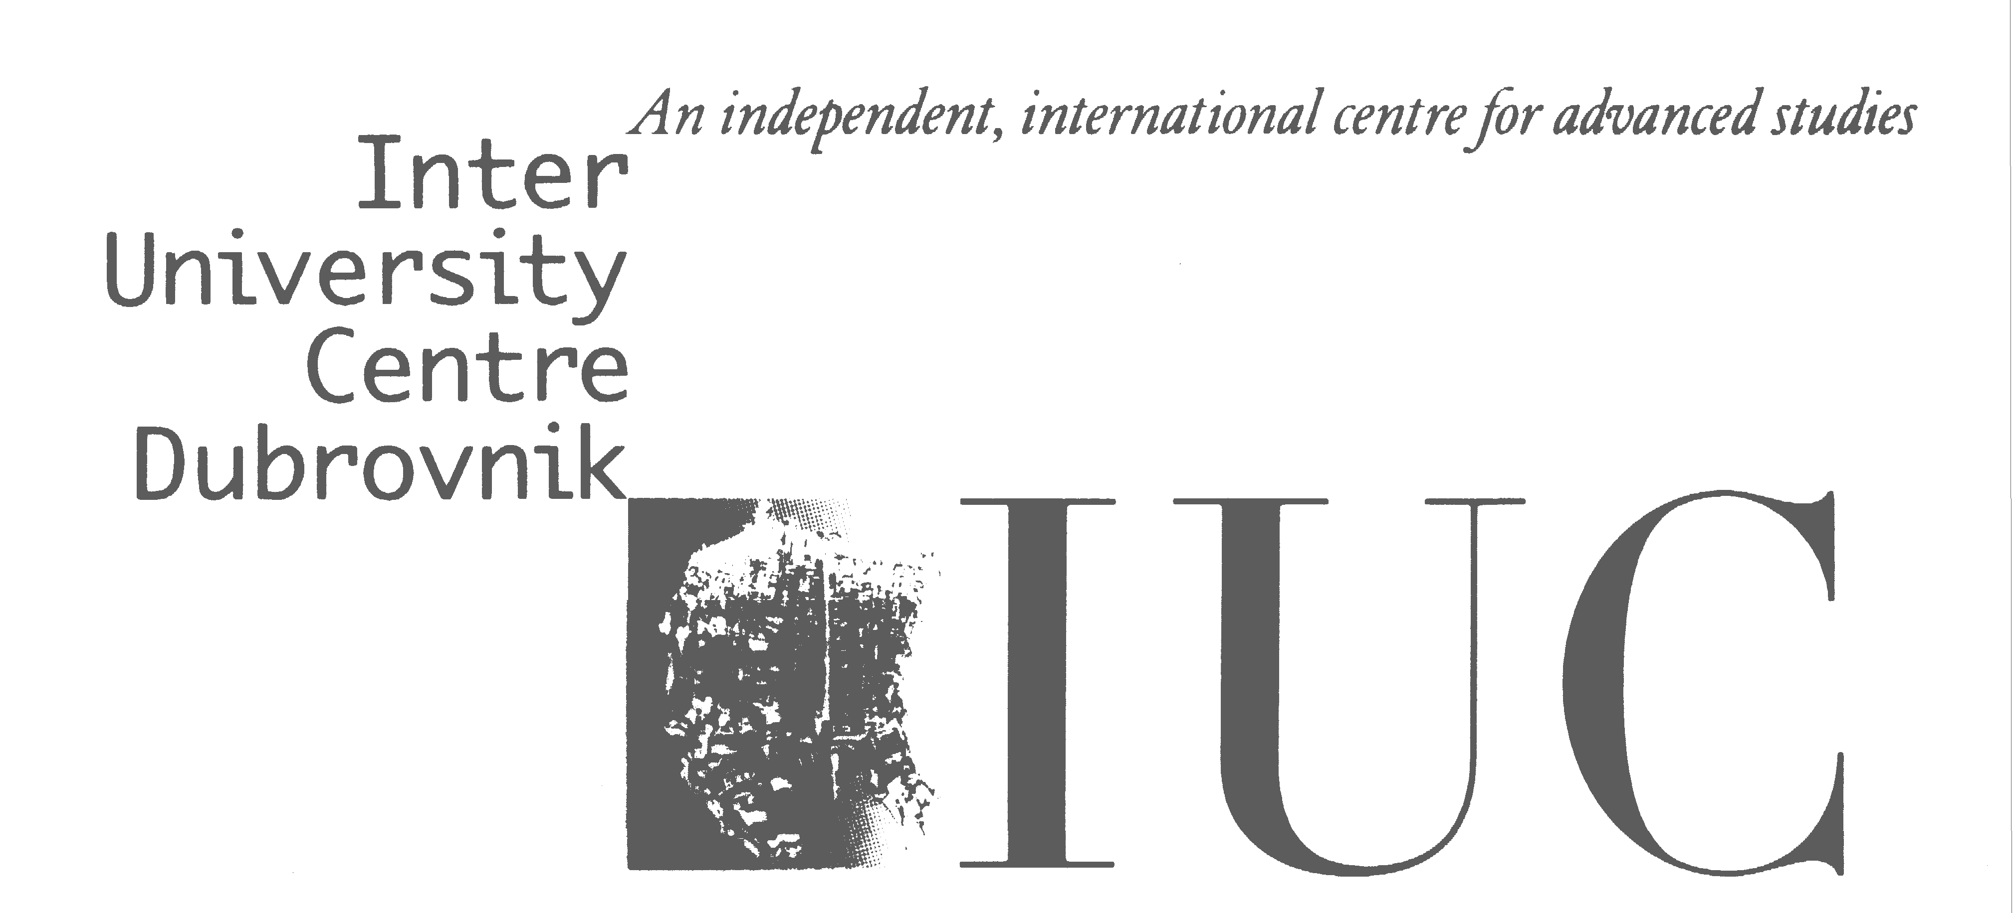
Public and Private Justice:
Dispute Resolution in Modern Societies

Judicial Precedents: Uniformity and Pluralism
Eighteenth PPJ Course and Conference (2024)
Monday, May 27  Registration (9,00 – 9,30)  Morning Session (9,30 – 13,00)  Welcome reception at the atrium of the IUC at 13,00  Afternoon Session  (15,00 – 18,00) | Luca Passanante (Brescia), Judicial Precedent in Comparative Perspective – An Outline  Richard Marcus (San Francisco), Possible Perils of Precedent: An American Cautionary Tale  Alan Uzelac (Zagreb), Overenthusiastic? The Pitfalls of Judicial Precedents in Civil Law Countries  Julius Schumann (Vienna), Nothing More Than Guidance? Past and Present Debates on the Role and Effect of Supreme Court Decisions in Austria and Germany  Bart Krans (Leiden), Dutch Prejudicial Question Act  Francesca Ferrari (Varese/Bruxelles), Precedents Italian Style
Tuesday, May 28  Morning Session (9,30 – 13,00)  Afternoon Session  (15,00 – 18,00) | João Marques Martins (Lisbon), Rules that Enhance the “Rule” of Persuasive Precedent  Hermes Zaneti (Vitoria), From Samba to Stare Decisis: The Rhythms of Legal Precedents in Brazil  Ramón García Odgers (Concepción), Building Uniformity through Case Management in Chilean Highest Courts  Christian Delgado (Lima), The ‘When’ and ‘Why’ of Judicial Precedents: Access Filters to Supreme Courts and Relevance
Wednesday, May 29  Morning session (9,00 – 12,00)  Afternoon Session  Study trip | Verica Trstenjak (Vienna/Ljubljana) & Jorg Sladič (Ljubljana/Leuven) How Does the Preliminary Rulings Procedure Ensure Uniformity of Case-law in Civil Litigation  Marta Requejo Isidro (Luxembourg), Precedent and the CJEU  Albert Henke (Milan), The 'Systemic' Effects of the 'Non-binding' Opinions Rendered by the European Court of Human Rights under Protocol N. 16'  Aleš Galič (Ljubljana), But do Material Facts Really Match: The problem of Mechanical Application of Precedents in Europe  Boat trip to Cavtat and Župa dubrovačka
Thursday, May 30  Morning Session (9,30 – 13,00)  Afternoon Session (15,00 – 18,00) | Viktória Harsági (Budapest), Introducing the Limited Precedent System in Hungarian Procedural Law  Piotr Rylski (Warsaw), How to Ensure Uniformity of Case Law in Civil Matters – The Example of the Polish Supreme Court  Marek Ivančo & Alexandra Löwy (Bratislava), Precedential Effects of Judgments under Slovak Law on Civil Litigation  Tatjana Zoroska-Kamilovska (Skopje), (Principled) Legal Opinions in Macedonian Judicial System: Do We Still Need Such Nomophylactic Methods?  Branka Babović Vuksanović (Belgrade), Between Tradition and European Integration: Methods for Ensuring the Uniform Application of Law in the Republic of Serbia
Friday, May 31  Morning Session (9,00 – 13,00) | Panel: Legal Aid Clinics – open discussion with the participation of clinical leaders and law clinics from Croatia and Europe)  Paul McKeown (Newcastle), Interdisciplinary Horizons: A Panoramic View of European Law Clinics  Biljana Đuričin (Podgorica), The Opportunities and Challenges of the Interdisciplinary Clinics: The American Experience  Ewelina Gee – Milan (Warsaw), Law Competitions and Their Importance for Innovative Teaching in Law Clinics – with Special Attention to the Example of The Brown Mosten Client Consultation Competition  Student roundtable (clinical students from Norway, Poland, and Croatia)

