**The International Conference**

**on the Future of Peace**

***The Role of the Academic Community in the Promotion of Peace***

**Conference co-organisers:**

**the Croatian Association of the Club of Rome,**

**the University of Zagreb**

**and**

**the Inter University Centre Dubrovnik**

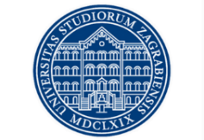 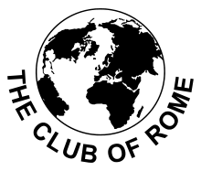 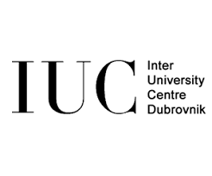

**Croatian Association**

**Club of Rome**

**With the support of**

**the Ministry of Science and Education of the Republic of Croatia**

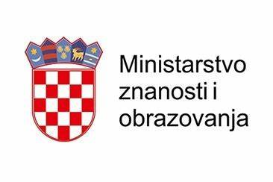

**Place: IUC Dubrovnik/online ZOOM**

**Time: 31.7 – 6.8.2022**

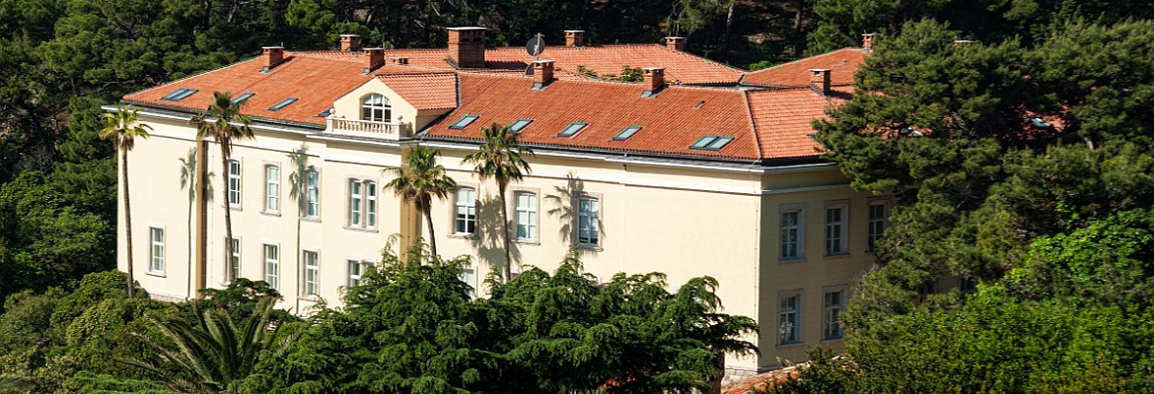

**IUC Dubrovnik**

**Program:**

**31.8.2022. (Sunday)**

17:00 Registration

18:00 Opening remarks:

**Prof. Hrvoje Kraljević**, Croatian Club of Rome, Croatia

**Prof. Goran Bandov,** University of Zagreb, Croatia

18:10 **Keynote speaker:**

**Academician Ivo Šlaus PhD,** Croatian Academy of Science and Art, Croatia

*Remember your Humanity and Forget the Rest*

18:40-19:30 Panel: *The Future of Peace: Challenges and Opportunities*

**Prof. Goran Bandov,** University of Zagreb, Croatia

**MP Domagoj Hajduković,** Croatian Parliament**,** Croatia

**Nuria Masdeu Pamies PhD,** SOAS University of London, UK

*Moderator:*

**Mr. Igor Kolman**, University of Zagreb, Croatia

**Welcome reception by the University of Zagreb**

**1.8.2022 (Monday)**

8:30 – 9:00 Registration

9:00 – 9:30 **Prof. Ivan Šimonović PhD,** University of Zagreb, Croatia

*Responsibility to Protect from Mass Atrocities*

9:30 – 10:00 **Prof. Snježana Prijić-Samaržija PhD,** University of Rijeka, Croatia

*Universities as the Lighthouses of the Values of Democracy, Social Justice, and Peace*

10:00 – 10:30 **MP Domagoj Hajduković,** Croatian Parliament, Croatia

*Rethinking EU role in Global Peace Building in the “New World Order” (after 24th February 2022)*

10:30 – 11:00 **Prof. Aleksander Zidanšek PhD,** Institut "Jožef Stefan", Slovenia

*Pathway to Peace in Europe*

11:00 – 11:30 Coffee break

11:30 – 12:00 **Prof. Phill Gittins PhD** World BEYOND War, UK

**Prof. Susan Cushman, PhD.** NCC/SUNY, USA

*When Academics and Non-Profits Collaborate: Innovative Peacebuilding Beyond the Classroom*

12:00 – 12:30 **Prof. Daci Jordan PhD,** Qiriazi University, Albania

*Promoting Human Rights via Obligatory Human Rights Teaching at University Studies as a Key Peace Promotion Instrument by the Academic Community*

12:30 – 13:00 **Mr.** **Božo Kovačević, former Ambassador,** Libertas University, Croatia

*Is the Second Cold War the Only Way to Avoid the Third World War?*

13:00 – 15:00 Lunch and free time

15:30 - 16:00 **Prof. Marko Savković PhD**

*The Challenge of Rapidly Shrinking Populations to Development and Peace in the Western Balkans*

16:00 – 16:30 **Mr. Ivan Marić,** Ministry of Foreign and European Affairs, Croatia

*Role of Power Sharing to Foster Peace and Ensure Stability in Times of Uncertainty*

16:30 – 17:00 **Prof. Tomislav Meštrović PhD,** University of North, Croatia

*Mortality and Disability Due to Conflict and Terrorism in European Sub-regions and Worldwide: Insights from the Global Burden of Disease 2019 Study*

**2.8.2022 (Tuesday)**

8:30 – 9:00 Registration

9:00 – 9:30**Ms. Nikolina Herceg Kolman, PhD Candidate,** The University of Zagreb, Croatia

*The Role of Academic Community in Developing and Supporting Democratic Political Culture*

9:30 – 10:00 **Ms. Patricia Garcia,** Institute for Economics and Peace, Australia

*Towards a Resilient and Sustainable Future with Positive Peace, Collaborations and Partnerships*

10:00 – 10:30 **Prof. Aleksandar Pavleski,** Ss. Cyril and Methodius University, North Macedonia

**Prof. Rade Rajkovčevski,** St. Kliment Ohridski University, North Macedonia

*Peacebuilding Model in the Higher Education: an Interdisciplinary Approach in the Context of Macedonian Society.*

10:30 – 11:00 **Prof. Darko Polšek PhD,** University of Zagreb, Croatia

*Is Reason Enough? Critical Notes Towards Machiavellian Approaches in the War in Ukraine*

11:00 – 11:30 Coffee break

11:30 – 12:00 **Mr. Federico Salvati, PhD Candidate,** FU Berlin, Germany

*Roles and Limitations of Legal Common Rules in Achieving Stability within the International System*

12:00 – 12:30 **Prof. Miloš Petrović PhD,** Institute of International Politics and Economics, Serbia

*International Higher-Education Cooperation in the Western Balkans in the Context of CEEPUS*

12:30 – 13:00 **Prof. Ace Milenkovski PhD,** University of Tourism and Management in Skopje, North Macedonia

**Prof. Sashe Gramatnikovski PhD,** University of Tourism and Management in Skopje, North Macedonia

*Tourism – Main Bridge for Building Understanding*

13:00 – 15:00 Lunch and free time

15:30 - 16:00 **Prof. Marina Savković PhD,** Singidunum University, Serbia

*Studying Outcomes for Peace, Justice and Strong Institutions – Student Competences Map*

16:00 – 16:30 **Prof. Juline Beaujouan-Marliere PhD, The University of Edinburgh**

*Knowledge Production at a Time of Pandemic – Navigating between Syria and the UK*

16:30 – 17:00 **Fr. Vedran Obučina, PhD Candidate,** University of Regensburg, Germany

*Religious Peacebuilding – Forgotten Part of Making Peace?*

***Dubrovnik war museum visit***

**3.8.2022 (Wednesday)**

8:30 – 9:00 Registration

9:00 – 9:30 **Prof. Boško Picula PhD,** University of Zagreb

*Southeast Europe between a Post-Cold War New World Order and the “New Cold War” Conflicts: Is Regional Peace Sustainable?*

9:30 – 10:00 **Prof. Rafał Majka PhD,** Andrzej Frycz Modrzewski Krakow University, Poland

*The Roles of the State, Academics and Community-based Organizations in Sexual and Mental Health Support Practises and Institutions for LGBTQ+ Migrants, Asylum Seekers and Refugees*

10:00 – 10:30 **Mr. Antônio Klaus Júnior Cláudio, PhD Candidate,** Alto Vale do Rio do Peixe University, Brazil

*Pro bono Work, Peace, and SDGs: An Experience Report of a Student and Researcher of the Alto Vale do Rio do Peixe University Law School at the Center of Legal Practices (NPJ)*

10:30 – 11:00 **Prof. Jana Ilieva PhD,** University of Tourism and Management in Skopje, North Macedonia

**Prof. Blagoj Conev PhD,** University of Tourism and Management in Skopje, North Macedonia

*The Role of Academic Community in Creating Public Opinion for Promotion of Peace in Conflict Societies*

11:00 – 11:30 Coffee break

11:30 – 12:00 **Prof. Cristina Blanco Sio-Lopez PhD,** Ca’ Foscari University of Venice, Italy

*Kant’s “Perpetual Peace”’ and the Building of a European Integration Process: Blueprints for an Alternate Future*

12:00 – 12:30 Ms. **Knežević Viktorija,** Law office Viktorija Knežević, Croatia

*Liquid Democracy Project*

12:30 – 13:00 **Ms. Vela Ariana MBA,** PhD Candidate, Avelante, Croatia

*Facilitating Peace trough EU Funds – Programs, Projects and Possibilities*

13:00 – 15:00 Lunch and free time

15:30 - 16:00 **Mr. Bardh Lipa, PhD Candidate,** The Pedagogical University of Krakow

*From an Anti-system Movement to Kosovo's Ruling Party: the Evolution of Lëvizja VETËVENDOSJE!*

16:00 – 16:30 **Ms.** **Nuria Masdeu Pamies PhD,** SOAS University of London, UK

*A Critical Approach to International Development Today: the Role of NGOs and Cooperation Agencies in Introducing a Peace-conducive Economic Development Framework.*

16:30 – 17:00 **Prof. Miaari Sami PhD,** Tel-Aviv University, Israel

**Prof. Massimiliano Calì1 PhD,** Tel-Aviv University, Israel

*Should I Trade or should I Go (to War)? Lessons from the Second Intifada*

**4.8.2022 (Thursday)**

8:30 – 9:00 Registration

9:00 – 9:30 **Ms. Ema Leto** University of Zagreb, Croatia

*Students' Impact on the Promotion of Peace*

9:30 – 10:00 **Ms. Bandov Ena,** University Josip Juraj Strossmayer in Osijek, Croatia

*Polio Eradication Movement And Road To Global Peace*

10:00 – 10:30 **Prof. Yürür Pinar PhD,** Mugla Sitki Kocman University, Türkiye

*The Effect of The EU: Soft Power Policies in The Western Balkans On Regional Peace And Turkey Role*

10:30 – 11:00 **Ms.** **Martina Plantak PhD**, Andrassy University Budapest, Hungary

*The Role of Music in Promotion of Peace*

11:00 – 11:10 **Prof. Goran Bandov**, University of Zagreb, Croatia

*The Future of (Our) Peace Projects Part I*

11:10 – 11:30 Coffee break

11:30 – 13:00 Workshop 1st session:

**Mr. Martin Scott,** Mediators Beyond Borders INTERNATIONAL, USA

*Neuroscience of Trauma and Peacebuilding: Applying Trauma-informed Practices in Mediation and Facilitation to Support IDPs in Ukraine*

13:00 – 15:00 Lunch free time

15:30 – 17:00 Workshop 2nd session:

**Mr. Martin Scott,** Mediators Beyond Borders INTERNATIONAL, USA

*Neuroscience of Trauma and Peacebuilding: Applying Trauma-informed Practices in Mediation and Facilitation to Support IDPs in Ukraine*

**5.8.2022 (Friday)**

8:30 – 9:00 Registration

9:00 – 9:30 **Group work project – Introduction**

9:30 – 13:00 **Group work project**

13:00 – 15:00 Lunch free time

15:30 – 17:00 **Results of the group(s) work project(s)**

**6.8.2022 (Saturday)**

8:30 – 9:00 Registration

9:00 – 10:00 **Final conclusion**

10:00 – 11:00 **Closing ceremony**

13:00 – 15:00 Lunch and free time

15:00 **Prof. Goran Bandov**, University of Zagreb, Croatia

*The Future of (Our) Peace Projects Part II*

7.8.2022 (Sunday) – 9.8.2022 (Tuesday)

**Work on the project ideas at the IUC Dubrovnik (***optional for participants***).**

*This document was created with the financial support of the Ministry of Science and Education of the Republic of Croatia. The content of this document is the sole responsibility of the Croatian Association of the Club of Rome and under no circumstances can it be considered as a reflection of the position of the Ministry.*