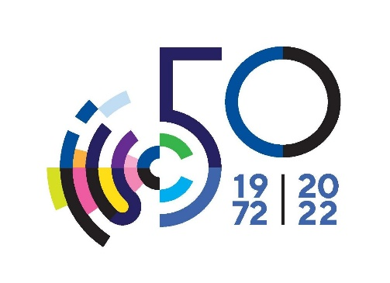

**IUC 50th Anniversary Conference and 17th IUC Council Meeting**

**Dubrovnik, 29 September – 1 October, 2022**

**PRACTICAL INFORMATION**

The programme is free of charge.

The IUC has secured some rooms in the below accommodation units. Please make sure to indicate this upon booking.

If you need any additional help in finding accommodation, please contact us at [iuc@iuc.hr](mailto:iuc@iuc.hr).

See for contact and transport: <https://iuc.hr/about/how-to-reach-us>.

Please register for the conference at this [**LINK**](https://forms.gle/sRUTVuWA9xoZYNTx9).

|  |  |  |
| --- | --- | --- |
| Hotel | Accommodation | Contact |
| Dormitory  **  Don Frana Bulića 4  20 000 Dubrovnik  <https://www.dormitory.hr/> | Single Room/47 Euro  Double Room/42 Euro  Breakfast included | IUC Office  [iuc@iuc.hr](mailto:iuc@iuc.hr)  Tel: +385 20 413 626 |
| Hotel Lero  ****  Iva Vojnovića 14  20 000 Dubrovnik  <https://hotel-lero.hr/> | Double Room/140 Euro  Single Use/130 Euro  Breakfast included | [marija.raguz-besjedica@hotel-lero.hr](mailto:marija.raguz-besjedica@hotel-lero.hr)  Tel: +385 20 341 435 |
| Valamar Lacroma Dubrovnik Hotel 4****  Ulica Vatroslava Lisinskog 15 A20 000 Dubrovnik  <https://www.valamar.com/en/hotels-dubrovnik/valamar-lacroma-dubrovnik-hotel> | Single Room/160 Euro  Double Room/175 Euro  Breakfast included  Rooms available based on availability | [josip.vukovic@valamar.com](mailto:josip.vukovic@valamar.com)  Tel: + 385 20 410 500 |
| Private accommodation  Pile Area  LS Adriatic Agency  [info@lsadriatic.com](mailto:info@lsadriatic.com) | On request | [info@lsadriatic.com](mailto:info@lsadriatic.com)  Tel: +385 98 480 742 |