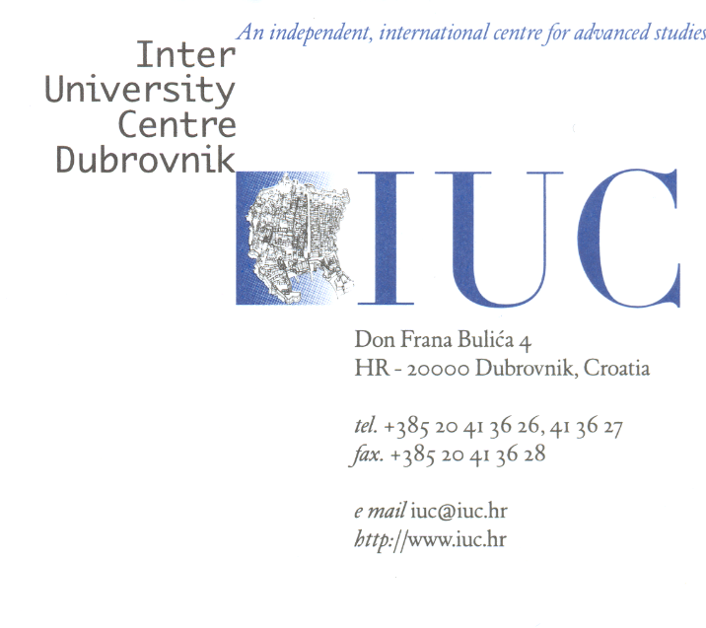

### PAYMENT INFORMATION

### for the donation to the IUC SCHOLARSHIP FUND

As an institution contributing to trans-national collaboration within academic community, one of the IUC’s incentives is to make its programs accessible to young scholars from the economically less developed regions.

The IUC Scholarship is intended for PhD students or young faculty membersfrom certain SE and E European and N African countries, studying or teaching in the field of social sciences and humanities and attending certain IUC postgraduate courses. Candidates must be under 35 years of age and nationals and permanent residents of one of the following countries*: Albania, Algeria, Armenia, Azerbaijan, Belarus, Bosnia & Herzegovina, Egypt, Kosovo, Kyrgyzstan, Libya, Macedonia, Moldova, Montenegro, Morocco, Republic of Georgia, Serbia, Tunisia and Ukraine.*

More on the page: [**https://www.iuc.hr/iuc-support.php**](https://www.iuc.hr/iuc-support.php)

**By supporting this fund, you would enable more scholars to be a part of the IUC academic community.**

Payment (without charge to the IUC) is made to the account:

**UDRUGA INTER-UNIVERZITETSKI CENTAR**

**IBAN: HR4824070001100615218**

**SWIFT: OTPVHR2X**

At:

OTP bank d.d.

Domovinskog rata 61

21 000 Split, Croatia

**Please indicate that this is the contribution to the IUC SCHOLARSHIP FUND.**

Your contribution will be made public on our web pages

<https://www.iuc.hr/iuc-support.php>.

If you wish, your contribution can also be anonymous.

**Inter-University Centre Dubrovnik** is registered as a non-profit NGO and under the Croatian law on VAT, article 90, all payments are tax-exempt.

VAT no: 17492194551

PAST GRANTEES’ EXPERIENCES:

Biljana Đ., Serbia:

“I received the IUC grant to attend a workshop in social philosophy that regularly gathers world class academics and aspiring young scholars such as myself. Without this support, I would miss out this event and the opportunity to present my work in front of a group of attentive yet sharp interlocutors and to become part of wonderful IUC community.”

Evis G., Albania:

“…I was honored to participate on the 12th postgraduate course Feminisms in a Transnational Perspective: Fear, Resistance, Imagination, organized by **IUC**…

…Participating for the first time in a well-organized course with different backgrounds personalities in the humanities field offers me new prospective on considering the topics by other optics. The way of transmitting emotions, the perception of the phenomena on different ways, the continues fight to improve the situation and to sensitize about the social problems brings together different points of view from academic field to the practical solutions… And another support is the cover of financial expenses. And, I was one of the grantees of this course.

It was an important help which offers me the opportunity to attend and to be part of this impressive group and experience. Without this support I’m sure that it will be very difficult for me to participate. I’m a university lecturer but the my salary is not so high to carry out these courses.

By the other side, the university does not offer such a support which leaves the academics in a difficult position. They have the obligation to attend and participate in conferences which will give them high score in academic progress but at the same time do not provide means to help them to attend and cover their academic progress.

For this reason, I’m very grateful to the organizers who make possible my attendance to this course, an added value in my professional as well as personal education. “

JOVANA Š., Serbia:

“I am student of PhD studies on department for social work and social policy, and I work as teaching assistant at Faculty of Philosophy – University of Novi Sad, Serbia.

I am incredibly grateful to have been chosen as a recipient of the IUC scholarship. On this way, I also want to express my admiration of Inter University Centre (Dubrovnik) and their programs. While at this University, I have had the chance to explore deeper my interests, and also to participated in different types of lectures and workshops. Further, I have been able to speak with individuals from many different cultures and backgrounds, and have had the chance to exchange opinions with experts from different fields. The experience that you provided is very valuable and important for me personally, as well as professionally.”